


S-101
Published by the
International Hydrographic Organization
4b quai Antoine 1er
Principauté de Monaco
Tel: (377) 93.10.81.00
Fax: (377) 93.10.81.40
info@iho.int
www.iho.int
IHO Electronic Navigational Chart (ENC) Product Specification

Edition 2.1.0.20260326 – Xxxx 2026

© Copyright International Hydrographic Organization 2026
This work is copyright. Apart from any use permitted in accordance with the Berne Convention for the Protection of Literary and Artistic Works (1886), and except in the circumstances described below, no part may be translated, reproduced by any process, adapted, communicated or commercially exploited without prior written permission from the International Hydrographic Organization (IHO). Copyright in some of the material in this publication may be owned by another party and permission for the translation and/or reproduction of that material must be obtained from the owner.
This document or partial material from this document may be translated, reproduced or distributed for general information, on no more than a cost recovery basis. Copies may not be sold or distributed for profit or gain without prior written agreement of the IHO Secretariat and any other copyright holders.
In the event that this document or partial material from this document is reproduced, translated or distributed under the terms described above, the following statements are to be included:
“Material from IHO publication [reference to extract: Title, Edition] is reproduced with the permission of the IHO Secretariat (Permission No ……./…) acting for the International Hydrographic Organization (IHO), which does not accept responsibility for the correctness of the material as reproduced: in case of doubt, the IHO’s authentic text shall prevail. The incorporation of material sourced from IHO shall not be construed as constituting an endorsement by IHO of this product.”
“This [document/publication] is a translation of IHO [document/publication] [name]. The IHO has not checked this translation and therefore takes no responsibility for its accuracy. In case of doubt the source version of [name] in [language] should be consulted.”
The IHO Logo or other identifiers shall not be used in any derived product without prior written permission from the IHO Secretariat.

Contents
Introduction 1
1 Overview 2
1.1 Scope 2
1.2 References 2
1.3 Terms, definitions and abbreviations 3
1.3.1 Use of language 3
1.3.2 Terms and definitions 3
1.3.3 Abbreviations 7
1.4 General S-101 data product description 8
1.5 Data Product Specification metadata 8
1.6 IHO Product Specification maintenance 9
1.6.1 Introduction 9
1.6.2 New Edition 9
1.6.3 Revision 9
1.6.4 Clarification 9
1.6.5 Version numbers 9
2 Specification Scope 10
3 Dataset Identification 10
4 Data Content and Structure 11
4.1 Introduction 11
4.2 Application Schema 11
4.3 Feature Catalogue 11
4.3.1 Introduction 11
4.3.2 Feature types 11
4.3.3 Feature relationships 12
4.3.4 Information types 13
4.3.5 Information relationships 13
4.3.6 Attributes 13
4.4 Feature Object Identifier 14
4.5 Dataset 14
4.5.1 Introduction 14
4.5.2 Dataset rules 14
4.5.3 Data Coverage rules 15
4.5.4 Dataset size 16
4.6 Display scale range 16
4.7 Dataset loading and display order 17
4.7.1 Dataset loading algorithm (dataset selection) 17
4.7.2 Dataset display order (dataset rendering) 17
4.8 Geometry 19
4.8.1 S-100 level 3a geometry 19
4.8.2 Use of scale properties for feature to geometry relations 21
4.8.3 Masking 21
5 Coordinate Reference Systems (CRS) 22
5.1 Introduction 22
5.2 Horizontal Coordinate Reference System 22
5.3 Vertical CRS for Soundings 22
6 Data Quality 24
6.1 Introduction 24
6.2 Completeness 25
6.2.1 Commission 25
6.2.2 Omission 25
6.3 Logical consistency 25
6.3.1 Conceptual consistency 25
6.3.2 Domain consistency 25
6.3.3 Format consistency 26
6.3.4 Topological consistency 26
6.4 Positional uncertainty and accuracy 26
6.4.1 Absolute or external accuracy 26
6.4.2 Vertical position accuracy 26
6.4.3 Horizontal position accuracy 26
6.4.4 Relative or internal accuracy 26
6.4.5 Gridded data positional accuracy 26
6.5 Thematic accuracy 27
6.5.1 Thematic classification correctness 27
6.5.2 Non-quantitative attribute accuracy 27
6.5.3 Quantitative attribute accuracy 27
6.6 Temporal quality 27
6.6.1 Temporal consistency 27
6.6.2 Temporal validity 27
6.6.3 Temporal accuracy 28
6.7 Aggregation 28
6.8 Data compliance and usability 28
7 Data Capture and Classification 28
8 Maintenance 28
8.1 Introduction 28
8.2 Maintenance and update frequency 28
8.3 Data source 29
8.4 Production process 29
8.5 Feature and Portrayal Catalogue management 29
9 Portrayal 29
9.1 Introduction 29
9.2 Portrayal Catalogue 30
10 Data Product Format (Encoding) 30
10.1 Introduction 30
10.1.1 Encoding of latitude and longitude 31
10.1.2 Encoding of depths as coordinates 31
10.1.3 Numeric attribute encoding 31
10.1.4 Text attribute values 31
10.1.5 Unknown attribute values 31
11 Data Product Delivery 31
11.1 Introduction 31
11.2 Exchange Set 31
11.3 Dataset 32
11.3.1 Datasets 32
11.3.2 Dataset file naming 32
11.3.3 New Editions, re-issues, updates and cancellations 33
11.4 Support files 33
11.4.1 ENC support files 33
11.4.2 System support files 33
11.4.3 ENC support file naming 33
11.4.4 Support file management 34
11.5 Associated XML Metadata file 36
11.6 S-101 Exchange Catalogue 37
11.7 Data integrity and encryption 37
12 Metadata 37
12.1 Introduction 37
12.1.1 S100_ExchangeCatalogue 39
12.1.2 S100_DatasetDiscoveryMetadata 40
12.1.3 S100_SupportFileDiscoveryMetadata 48
12.1.4 S100_CatalogueDiscoveryMetadata 50
12.2 Language 52
ANNEX A - Data Classification and Encoding Guide 53
ANNEX B (Normative) - Data Product format (encoding) 55

Document History
Changes to this Specification are coordinated by the S-101 Project Team (S-101PT), a Project Team under the IHO S-100 Working Group (S-100WG). New editions will be made available via the IHO web site. Maintenance of the Specification shall conform to IHO Resolution 2/2007 (as amended).
Version Number | Date | Approved By | Purpose
Phase 1 | May 2009 | J. Powell | Initial Draft.
Phase 1 | June 2010 | J. Powell | Merged all the phases back into a single document.
Phase 1 | July 2010 | J. Powell | Added comments from AHO.
Phase 1 | September 2010 | J. Powell | Revised based on FG discussions.
Phase 1 | December 2010 | J. Powell | Revised based on TSMAD 21.
Phase 1 | February 2011 | J.Powell | Revised based on comments to phase 1 from 2J, FR, AU.
Phase 2 | April 2011 | J.Powell | Revised based on comments from TSMAD22. Changed version to 0.1.0 to reflect movement to phase 2.
Phase 2 | November 2011 | J.Powell | Revisions made based on comments from discussion papers circulated post TSMAD 22.
Phase 3 | February | J.Powell | Revisions made based on TSMAD23 decisions.
Phase 3 | May 2012 | J.Powell | Added TSMAD24 Decisions into document.
Phase 4 | August 2012 | J.Powell | Edited document to reflect TSMAD24 decisions.
Phase 4 | November 2012 | J.Powell | Added comments from October 2012 round of TSMAD comments.
Initial Draft | March 2013 | J.Powell | Added comments from January 2013 round of TSMAD comments.
Initial Draft | June 2013 | J.Powell | Added decisions from TSMAD26.
Initial Draft | December 2013 | J.Powell | Added in decisions from TSMAD27.
Draft 0.0.0 | April/May 2014 | S-100WG | Included S-101 portrayal. Most of the portrayal is covered by the catalogue, so much of the old S-52 guidance goes into the implementation guidance annex.
Draft 0.0.1 | February 2015 | S-100WG | Added adjudicated comments from TSMAD29.
Draft 0.0.2 | January 2016 | S-100WG | Incorporated editorial issues that were noted in draft 0.0.1. Also includes a revised metadata section.
Draft 0.0.2 | July 2017 | S-100WG | Incorporated the decisions from S101PT1 and updated some editorial issues. Numbering remained the same to be consistent with the DCEG numbering.
Draft 1.0.0 | October 2018 | S-100WG | Editorial S-101PT review and clean-up in preparation for final approval to publish as Edition 1.0.0.
Draft 1.1.0 | December 2022 | S-100WG | New version for implementation and testing, updated to align with S-100 Edition 5.0.0.
Draft 1.2.0 | March 2024 | S-100WG | New version for implementation and testing, updated to align with S-100 Edition 5.1.0.
2.0.0 | December 2024 | IHO CL 02-2025 | Initial operational Edition of S-101, updated to align with S-100 Edition 5.2.0.
2.1.0 | Xxxx 2025 | IHO CL xx-2025 | Revision to incorporate ….

Summary of Substantive Changes from Edition 2.0.0

Bold references in the Clauses Effected column indicate the principle sections/clauses that are impacted by the described change.
Change Summary | Clauses Affected
Added a new Note that feature and attribute aliases, including corresponding S-57 acronyms, have been included in the Feature Catalogue for implementation cross-referencing purposes during the dual-fuel implementation period. | 4.3.1
Clarified that the optimum display scale for the entire dataset is defined in S100_DatasetDiscoveryMetadata; and that where a dataset has multiple Data Coverage features, the value for maximum display scale populated in the S100_DatasetDiscoveryMetadata must be an empty (null) value. | 4.5.3
Increased maximum allowable file size for ENC Update datasets from 200kb to 300kb. | 4.5.4
Clarified that the fixed scale values defined for minimum display scale and optimum display scale only must be taken from the values in Table 3-1; and scale value for maximum display scale can be any numeric value. | 4.6
Clarified that the display of the “gross overscale” pattern in ECDIS is applied in accordance with S-98 Main document, clause 12.3.3. | 4.6
Amended reference to S-101 Dataset Loading and Display (Rendering) Algorithms to S-98 Appendix E. | 4.7, 4.7.1, 4.7.2
Corrected CRNM vertical component subfield for the CRSH field in the compound CRS encoding examples at tables 5-1 and 5-2 to remove the text “Depth – “. | 5.3
Added guidance on the requirement for an Exchange Set to contain a digital signature (CATALOG.SIGN) file. | 11.2
Added guidance on the mandatory requirement to digitally sign datasets for inclusion in an Exchange Set. | 11.3.1
Added guidance that ENC support files included in the Exchange Set are referenced by the attributes file reference and pictorial representation. | 11.4.1
Amended multiplicity of supportFileSpecification field for S100_SupportFileDiscoverymetadata from [1] to [0..1]. | 12.1.3
Corrected Remark for S100_SupportFileFormat value TIFF to state that this is the only format allowed for pictorial ENC support files. | 12.1.3.1
Amended column name for Field Content Tables from “Comment” to “Subfield content and specification”. | B-5.1, B-6.1, B-7.1
Removed the restriction on the value and added a more general comment for the CRNM subfield of the CRSH field. | B-5.1.10
Extended the remark for the DTNM subfield of the VDAT field to specify the name of the datum as included in the Feature Catalogue. Added value restriction for the DTID subfield. | B-5.1.12
Amended subfield comment for the SMAX subfield of the SPAS field to specify that a NULL value is {2³²-1} and not {0}. | B-5.1.31, B-6.1.30
Amended subfield comments for COCC-NCOR, SECC-NSEG and CCOC-NCCO to recognise that for a Delete instruction there should be no items present. | B-6.1.18, B-6.1.21, B-6.1.24

Introduction
S-101 is the Electronic Navigational Chart (ENC) Product Specification, produced by the International Hydrographic Organization. S-101 is designed to allow content, content definition (Feature Catalogues) and presentation (Portrayal Catalogues) to be updateable as “Plug and Play” system implementations.
Based on the IHO Universal Hydrographic Data Model S-100, S-101 includes all the necessary components for both Hydrographic Offices to produce Electronic Navigational Charts (ENCs); and marine navigation systems (principally Electronic Chart Display and Information Systems (ECDIS)) to be able to ingest and properly display them. This Product Specification is designed to be flexible with the introduction of machine-readable Feature and Portrayal Catalogues that will allow for managed change; and will enable the introduction of new navigationally significant features and their portrayal using a “just in time” methodology.

Overview

Scope
This document describes an S-100 compliant Product Specification for Electronic Navigational Charts, which will form the base navigation layer for an S-100 based marine navigation system. It specifies the content, structure, and metadata needed for creating a fully compliant S-101 ENC and for its portrayal within an S-100 system. This Product Specification includes the content model, the encoding, the Feature Catalogue, Portrayal Catalogue, metadata, and implementation guidance for developers.

References
S-52 IHO Specifications for Chart Content and Display Aspects of ECDIS, Edition 6.1(.1) – October 2014, with Clarifications up to June 2015
S-100 IHO Universal Hydrographic Data Model, Edition 5.2.0 – June 2024
ISO 639-2/T Codes for the representation of names of languages – Part 2: Alpha-3 code
ISO 3166-1 Codes for the Representation of Names of Countries and their Subdivisions – Part 1: Country Codes
ISO/IEC 8211:1994 Specification for a Data Descriptive File for Information Interchange Structure Implementations
ISO 8601:2004 Data Elements and Interchange Formats – Information Interchange – Representation of Dates and Times
ISO 19101:2003 Geographic Information – Reference Model
ISO 19103:2005 Geographic Information – Conceptual Schema Language
ISO 19103-2:2005 Geographic Information – Conceptual Schema Language – Part 2
ISO 19105:2000 Geographic Information – Conformance and Testing
ISO 19107:2003 Geographic Information – Spatial Schema
ISO 19108:2002 Geographic Information – Temporal Schema
ISO 19109:2005 Geographic Information – Rules for Application Schema
ISO 19110:2005 Geographic Information – Methodology for Feature Cataloguing
ISO 19111:2007 Geographic Information – Spatial Referencing by Coordinates
ISO 19113:2002 Geographic Information – Quality Principles
ISO 19115-1 Geographic information – Metadata – Part 1 - Fundamentals. As amended by Amendment 01 (2018)
ISO/TS 19115-3 Geographic information - Metadata - XML schema implementation for fundamental concepts
ISO 19117:2012 Geographic Information – Portrayal
ISO 19118:2005 Geographic Information – Encoding
ISO 19131:2008 Geographic Information – Data Product Specifications
ISO/TS 19138:2006 Geographic Information – Data Quality Measures
ISO 19157:2013 Geographic Information – Data Quality
ISO/IEC 19501:2005 Information Technology – Unified Modelling Language (UML), Version 1.4.2
FIPS 186 Federal Information Processing Standards – Digital Signature Standard

Terms, definitions and abbreviations

Use of language
Within this document:
- “Must” indicates a mandatory requirement.
- “Should” indicates an optional requirement, that is the recommended process to be followed, but is not mandatory.
- “May” means “allowed to” or “could possibly”, and is not mandatory.

Terms and definitions
Accuracy
Closeness of agreement between a test result and the accepted reference values.
NOTE: A test result can be from an observation or measurement.
Aggregation
Special form of association that specifies a whole-part relationship between the aggregate (whole) and a component part (see composition).
Alarm
(MSC.302/A) a high-priority alert. Condition requiring immediate attention and action by the bridge team, to maintain the safe navigation of the ship.
Alert
(MSC.302/A) announcement of abnormal situations and conditions requiring attention. Alerts are divided in four priorities: emergency alarms, alarms, warnings and cautions. An alert provides information about a defined state change in connection with information about how to announce this event in a defined way to the system and the operator.
Application Schema
Conceptual schema for data required by one or more applications.
Association
Semantic relationship between two or more classifiers that specifies connections among their instances.
NOTE: A binary association is an association among exactly two classifiers (including the possibility of an association from a classifier to itself)
Attribute
(1) Named property of an entity.
NOTE: Describes a geometrical, topological, thematic, or other characteristic of an entity.
(2) Feature within a classifier that describes a range of values that instances of the classifier may hold.
NOTE: An attribute is semantically equivalent to a composition association; however, the intent and usage is normally different.
NOTE: “Feature” used in this definition is the UML meaning of the term.
Boundary
Set that represents the limit of an entity.
NOTE: Boundary is most commonly used in the context of geometry, where the set is a collection of points or a collection of objects that represent those points.
Caution
(MSC.302/A) lowest priority of an alert. Awareness of a condition which does not warrant an alarm or warning condition, but still requires attention out of the ordinary consideration of the situation or of given information.
Class
Description of a set of objects that share the same attributes, operations, methods, relationships, and semantics.
NOTE: A class represents a concept within the system being modelled. Depending on the kind of model, the concept may be real-world (for an analysis model), or it may also contain algorithmic and computer implementation concepts (for a design model). A classifier is a generalization of class that includes other class-like elements, such as data type, actor and component.
Classification
The process of determining the appropriate data type within a feature catalogue for a particular real world feature, including consideration of data quality.
Composition
Form of aggregation association with strong ownership and coincident lifetime as part of the whole.
NOTE: Parts with non-fixed multiplicity may be created after the composite itself, but once created they live and die with it (that is, they share lifetimes). Such parts can also be explicitly removed before the death of the composite. Composition may be recursive. Synonym: Composite aggregation.
Coordinate
One of a sequence of n numbers designating the position of a point in n-dimensional space.
NOTE: In a coordinate reference system, the coordinate numbers are qualified by units.
Coordinate Reference System
Coordinate system that is related to an object by a datum.
NOTE: For geodetic and vertical datums, the object will be the Earth.
Coordinate Tuple
Ordered list of coordinates where the number and order of coordinates is identical to the axes of the coordinate reference system.
Curve
1-dimensional geometric primitive, representing the continuous image of a line.
NOTE: The boundary of a curve is the set of points at either end of the curve. If the curve is a cycle, the two ends are identical, and the curve (if topologically closed) is considered to not have a boundary. The first point is called the start point, and the last is the end point. Connectivity of the curve is guaranteed by the "continuous image of a line" clause. A topological theorem states that a continuous image of a connected set is connected.
Curve Segment
1-dimensional geometric object used to represent a continuous component of a curve using homogeneous interpolation and definition methods.
NOTE: The geometric set represented by a single curve segment is equivalent to a curve.
Data Product
A dataset or dataset series that conforms to a data product specification.
Data Quality
A set of elements describing aspects of quality, including a measure of quality, an evaluation procedure, a quality result, and a scope.
Data Type
Specification of a value domain with operations allowed on values in this domain.
NOTE: Data types include primitive predefined types and user-definable types.
NOTE: A data type is identified by a term, for example Integer.
EXAMPLES: Integer, Real, Boolean, CharacterString, DirectPosition and S_100_TruncatedDate
Dataset
An identifiable collection of data.
NOTE: A dataset may be a smaller grouping of data which, though limited by some constraint such as spatial extent or feature type, is located physically within a larger dataset. Theoretically, a dataset may be as small as a single feature contained within a larger dataset. A hardcopy map or chart may be considered a dataset.
Datum
Parameter or set of parameters that define the position of the origin, the scale, and the orientation of a coordinate system.
Display Priority
Display priorities control the order in which the output of the portrayal functions is processed by the rendering engine. Priorities with smaller numerical values will be processed first. Instructions which have equal display priority must be ordered so that area instructions are rendered first, followed by line instructions, then point instructions, and lastly text instructions. If the display priority is equal among the same type of instruction (area, line, point, or text) some other neutral criterion must be used to order the instructions.
ECDIS
A navigation information system which with adequate back-up arrangements can be accepted as complying with the up-to-date chart required by regulations V/19 and V/27 of the 1974 SOLAS Convention, as amended, by displaying selected information from a System Electronic Navigational Chart (System Database) with positional information from navigation sensors to assist the Mariner in route planning and route monitoring, and if required display additional navigation-related information.
ECDIS Chart 1
An ECDIS version of INT 1, including all symbols, line styles and colour coding used for chart presentation. Intended for the Mariner for both familiarization with ECDIS and to look up specific symbols.
Emergency Alarm
(MSC.302/A) highest priority of an alert. A condition presenting an immediate danger to human life or to the ship and its machinery exists and that immediate action must be taken.
ENC
The dataset, standardized as to content, structure and format, issued for use with ECDIS by or on the authority of a Government authorized Hydrographic Office or other relevant government institution, and conforming to IHO standards. The ENC contains all the chart information necessary for safe navigation and may contain supplementary information in addition to that contained in the paper chart which may be considered necessary for safe navigation.
ENDS
A special-purpose database compiled from nautical chart and nautical publication data, standardized as to content, structure and format, issued for use with ECDIS by or on the authority of a Government, authorized Hydrographic Office or other relevant government institution, and conforming to IHO standards; and, which is designed to meet the requirement of marine navigation and the nautical charts and nautical publications carriage requirements in SOLAS regulations V/19 and V/27. The navigational base layer of ENDS is the Electronic Navigational Chart (ENC).
Enumeration
A fixed list of valid identifiers of named literal values. Attributes of an enumeration type may only take values from this list.
Feature
Abstraction of real world phenomena.
NOTE: A feature may occur as a type or an instance. Feature type or feature instance should be used when only one is meant.
EXAMPLE: The phenomenon named ‘London Eye’ may be classified as a feature instance with other phenomena into a feature type ‘landmark’
Feature Association
Relationship that links instances of one feature type with instances of the same or a different feature type.
Feature Attribute
Characteristic of a feature.
NOTE: A feature attribute may occur as a type or an instance. Feature attribute type or feature attribute instance is used when only one is meant.
NOTE: A feature attribute type has a name, a data type and a domain associated to it. A feature attribute instance has an attribute value taken from the value domain of the feature attribute type.
NOTE: In a Feature Catalogue, a feature attribute may include a value domain but does not specify attribute values for feature instances.
EXAMPLE 1: A feature attribute named communication channel may have an attribute value VHF0007 which belongs to the data type text
EXAMPLE 2: A feature attribute named length may have an attribute value 82.4 which belongs to the data type real
Feature Catalogue
A catalogue containing definitions and descriptions of the feature types, feature attributes, and feature associations occurring in one or more sets of geographic data.
Geometric Primitive
Geometric object representing a single, connected, homogeneous element of geometry.
NOTE: Geometric primitives are non-decomposed objects that present information about geometric configuration. They include points, curves, surfaces, and solids.
Human Readable
A representation of information that can be naturally read by humans.
Identifier
A linguistically independent sequence of characters capable of uniquely and permanently identifying that with which it is associated.
Indication
Visual indication giving information about the condition of a system or equipment.
Instance
Entity to which a set of operations can be applied and which has a state that stores the effects of the operations.
NOTE: See feature.
Machine Readable
A representation of information that can be processed by computers.
Maximum Display Scale
The value considered by the Data Producer to be the maximum (largest) scale at which the data is to be displayed before it can be considered to be “grossly overscaled”.
Metadata
Data about data.
Minimum Display Scale
The minimum (smallest) scale with which the data is intended to be displayed.
Model
Abstraction of some aspects of universe of discourse.
NOTE: A semantically complete abstraction of a system.
Multiplicity
Specification of the number of possible occurrences of a property, or the number of allowable elements that may participate in a given relationship.
EXAMPLES: 1..* (one to many); 1 (exactly one); 0..1 (zero or one)
Optimum Display Scale
The maximum (largest) scale with which the data is intended to be displayed.
NOTE: Optimum Display Scale may be considered to be the compilation scale for the data, and is the reference for the overscale indication. When the Mariners Selected Viewing Scale (MSVS) is set to a scale that is larger than Optimum Display Scale, this triggers the overscale indication in the end user system.
Overscale
The viewing scale is larger than the value considered by the Data Producer to be the largest intended (optimum) display scale for the data.
Point
0-dimensional geometric primitive, representing a position.
NOTE: The boundary of a point is the empty set.
Pointset
A set of points in geometric space.
Portrayal Catalogue
Collection of defined portrayals for a feature catalogue.
NOTE: Content of a portrayal catalogue includes portrayal functions, symbols, and portrayal context.
Record
Finite, named collection of related items (objects or values).
NOTE: Logically, a record is a set of pairs <name, item >.
Relationship
Semantic connection among model elements.
NOTE: Kinds of relationships include association, generalization, metarelationship, flow, and several kinds grouped under dependency.
Scale Minimum
The smallest scale at which a feature is intended to be displayed (for example, a minor light, with a scale minimum of 1:45,000, would not normally be displayed at a scale of 1:90,000).
Skin of the Earth
A defined set of non-overlapping geographic features of geometric primitive surface, completely covering an area equivalent to that of meta-features Data Coverage.
Surface
Connected 2-dimensional geometric primitive, representing the continuous image of a region of a plane.
NOTE: The boundary of a surface is the set of oriented, closed curves that delineate the limits of the surface.
System Database
A database, in the manufacturer's internal ECDIS format, resulting from the lossless transformation of the Electronic Navigational Data Service (ENDS) contents and its updates. It is this database that is accessed by ECDIS for the display generation and other navigational functions, and is equivalent to up-to-date ENDS.
Temporal Reference System
Reference system against which time is measured.
Vertical Datum
Datum describing the relation of gravity-related heights or depths to the Earth.
Viewing Scale
The value of the ratio of the linear dimensions of features of a dataset presented in the display and the actual dimensions of the features represented of the dataset.
Warning
(MSC.302/A) alert for condition requiring immediate attention, but no immediate action by the bridge team. Warnings are presented for precautionary reasons to make the bridge team aware of changed conditions which are not immediately hazardous, but may become so if no action is taken.

Abbreviations
CRS Coordinate Reference System
DCEG Data Classification and Encoding Guide
ECDIS Electronic Chart Display and Information System
ENC Electronic Navigational Chart
ENDS Electronic Navigational Data Service
EPSG European Petroleum Survey Group
GFM General Feature Model
IEC International Electrotechnical Commission
IHO International Hydrographic Organization
IMO International Maritime Organization
ISO International Organization for Standardization
MSVS Mariners Selected Viewing Scale
SOLAS Safety of Life at Sea
SVG Scalable Vector Graphics
S-100WG IHO S-100 Working Group
S-101PT S-100WG – S-101 Project Team
TIFF Tagged Image File Format
UML Unified Modelling Language
URL Universal Resource Locator
XML Extensible Markup Language

General S-101 data product description
NOTE: This clause contains general information about the data product.
Title: Electronic Navigational Chart
Abstract: An Electronic Navigational Chart (ENC) is a vector chart produced on the authority of a government authorized Hydrographic Office or other relevant government institution. Its primary purpose is for use within an Electronic Chart Display and Information System (ECDIS) to meet International Maritime Organization (IMO) and Safety of Life at Sea (SOLAS) chart carriage requirements; however it may also be used as the base dataset in other S-100 based marine navigation systems. The ENC contains an extraction of real world information necessary for the safe navigation of vessels.
Content: The Product Specification defines all requirements to which ENC data products must conform. Specifically it defines the data product content in terms of features and attributes within the Feature Catalogue. The display of features is defined by the symbols and rule sets contained in the Portrayal Catalogue. The Data Classification and Encoding Guide (DCEG) provides guidance on how data product content must be captured. (Annex A.)
Spatial Extent:
Description: Areas specific to marine navigation.
East Bounding Longitude: 180°
West Bounding Longitude: -180°
North Bounding Latitude: 90°
South Bounding Latitude: -90°
Purpose: The purpose of an ENC dataset is to provide official navigational data for navigation systems for the safe passage and route planning of vessels between destinations.

Data Product Specification metadata
NOTE: This information uniquely identifies this Product Specification and provides information about its creation and maintenance. For further information on dataset metadata see clause 12.
Title: The International Hydrographic Organization Electronic Navigational Chart Product Specification
S-100 Version: 5.2.0
S-101 Version: 2.1.0
Date: Xxxx 2026
Language: English
Classification: Unclassified
Contact: International Hydrographic Organization
4b Quai Antoine 1er
B.P. 445
MC 98011 MONACO CEDEX
Telephone: +377 93 10 81 00
Fax: +377 93 10 81 40
Email: info@iho.int
URL: www.iho.int
Identifier: S-101
Maintenance: Changes to the Product Specification S-101 are coordinated by the S-101 Project Team (S-101PT), a Project Team under the IHO S-100 Working Group (S-100WG), and must be made available via the IHO web site. Maintenance of the Product Specification must conform to IHO Resolution 2/2007, as amended.

IHO Product Specification maintenance

Introduction
Changes to S-101 will be released by the IHO as a New Edition, revision, or clarification.

New Edition
New Editions of S-101 introduce significant changes. New Editions enable new concepts, such as the ability to support new functions or applications, or the introduction of new constructs or data types. New Editions are likely to have a significant impact on either existing users or future users of S-101. All cumulative revisions and clarifications must be included with the release of approved New Editions.

Revision
Revisions are defined as substantive semantic changes to S-101. Typically, revisions will change S-101 to correct factual errors; or introduce necessary changes that have become evident as a result of practical experience or changing circumstances. A revision must not be classified as a clarification. Revisions could have an impact on either existing users or future users of S-101. All cumulative clarifications must be included with the release of approved revisions.
Changes in a revision are minor and ensure backward compatibility with the previous versions within the same Edition. Newer revisions, for example, introduce new features and attributes. Within the same Edition, a dataset of one version could always be processed with a later version of the Feature and Portrayal Catalogues.
In most cases a new Feature Catalogue or Portrayal Catalogue will result in a revision of S-101.

Clarification
Clarifications are defined as non-substantive changes to S-101. Typically, clarifications: remove ambiguity; correct grammatical and spelling errors; amend or update cross references; and insert improved graphics. A clarification must not cause any substantive semantic change to S-101.
Changes in a clarification are minor and ensure backward compatibility with the previous versions.

Version numbers
The associated version control numbering to identify changes (n) to S-101 must be as follows:
New Editions denoted as n.0.0
Revisions denoted as n.n.0
Clarifications denoted as n.n.n

Specification Scope
Scope ID: Global
Level: 006 - series
Level name: ENC Dataset

Dataset Identification
A dataset that conforms to this Product Specification may be identified by its discovery metadata as defined in clause 12.
Title: Electronic Navigational Chart
Alternate Title: ENC
Abstract: ENCs must be produced in accordance with the rules defined in the S-101 Product Specification. The S-101 Product Specification contains all the information necessary to enable Hydrographic Offices to produce a consistent ENC; and manufacturers to use that data within navigation systems.
Topic Category: Transportation (ISO 19115-1 MD_TopicCategoryCode 018)
Geographic Description: Areas specific to marine navigation
Spatial Resolution: An ENC dataset and Data Coverage features must carry a value for optimum display scale. Each Data Coverage feature must also carry a value for maximum and minimum display scale. Values for optimum and minimum display scales must be taken from the following Table:
Table 3-1 – ENC Minimum Display and Optimum Display Scales
Scale
NULL (only allowed on minimum display scale (data will continue to be displayed at all smaller scales))
1:10,000,000
1:3,500,000
1:1,500,000
1:700,000
1:350,000
1:180,000
1:90,000
1:45,000
1:22,000
1:12,000
1:8,000
1:4,000
1:3,000
1:2,000
1:1,000 (only allowed on optimum and maximum display scale)

Purpose: Electronic Navigational Chart for use in Electronic Chart Display and Information Systems
Language: English (Mandatory), other (Optional)
Classification: Data may be classified as one of the following:
1) Unclassified;
2) Restricted;
3) Confidential;
4) Secret;
5) Top Secret;
6) Sensitive but Unclassified;
7) For Official Use Only;
8) Protected; or
9) Limited Distribution.
Spatial Representation Type: Vector
Point of Contact: Producing Agency
Use Limitation: Not to be used for navigation on land

Data Content and Structure

Introduction
An S-101 ENC is a feature-based product. The content information is described in terms of a General Feature Model and a Feature Catalogue.

Application Schema
S-101 conforms to the General Feature Model (GFM) from S-100 Part 3. The GFM is the conceptual model and the implementation is defined in the Feature Catalogue. The S-101 Application Schema is realised in the Feature Catalogue and the Product Specification only contains specific examples.

Feature Catalogue

Introduction
The S-101 Feature Catalogue describes the feature types, information types, attributes, attribute values, associations and roles which may be used in an ENC.
The S-101 Feature Catalogue is available in an XML document which conforms to the S-100 XML Feature Catalogue Schema and can be downloaded from the IHO website. S-101 Annex A – Data Classification and Encoding Guide, constitutes a human readable interpretation of the Feature Catalogue.
NOTE: For this Edition of S-101, the list of feature and attribute aliases, including corresponding S-57 acronyms, have been included in the Feature Catalogue to provide a useful cross-reference for S-101 implementers during the dual-fuel implementation period. These aliases will be removed in a future Edition of the S-101 Feature Catalogue as they do not perform any role/function in Feature Catalogue implementation in ECDIS.

Feature types
Details of feature types can be found in Annex A – Data Classification and Encoding Guide, clause 2.1 and Sections 3-23.

Geographic
Geographic (geo) feature types form the principal content of the ENC and are fully defined by their associated attributes and information types.
Details of geographic feature types can be found in Annex A – Data Classification and Encoding Guide, clause 2.1 and Sections 4-22.

Skin of the Earth
Details of features comprising the Skin of the Earth can be found in Annex A – Data Classification and Encoding Guide, clause 2.5.1.1.

Metadata features
Details of metadata feature types can be found in Annex A – Data Classification and Encoding Guide, clause 2.1 and Section 3.

Cartographic
Details of cartographic feature types can be found in Annex A – Data Classification and Encoding Guide, clause 2.1 and Section 23.

Feature relationships
A feature relationship links instances of one feature type with instances of the same or a different feature type. There are three types of defined feature relationships in S-101 as described in the following sub clauses.

Feature association
A feature association is used to describe a relationship between two feature types that involves connections between their instances.
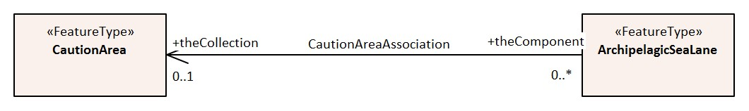
EXAMPLE: A Caution Area feature provides additional caution information to the Archipelagic Sea Lane feature. An association named Caution Area Association is used to relate the two features; roles are used to convey the meaning of the relationship.
Figure 4-1 – Feature association

Aggregation
An aggregation is a relationship between two or more feature types where the aggregation is made up of component features.
EXAMPLE: An Island Group feature may be composed of multiple Land Area features to indicate the name of a group of islands.
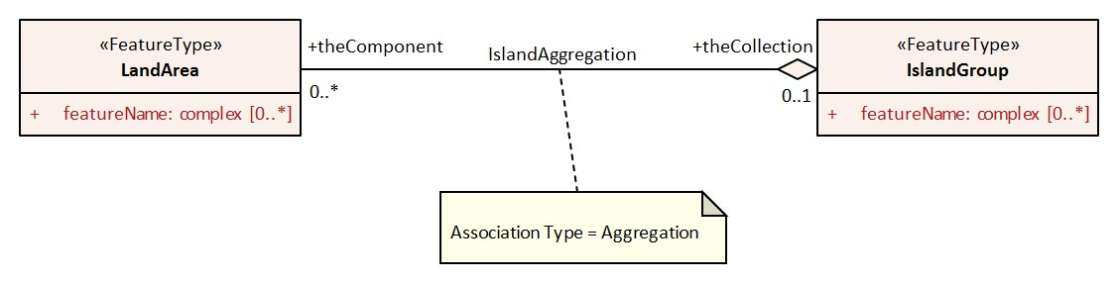
Figure 4-2 – Aggregation

Composition
A composition is a strong aggregation. In a composition, if a container feature is deleted then all of its containee features are deleted as well.
EXAMPLE: If a feature type that is considered a structure feature, such as a beacon, is deleted, then all of its component feature types that make up the equipment composition, such as lights and fog signals must be deleted as they make up the Structure/Equipment Composition.
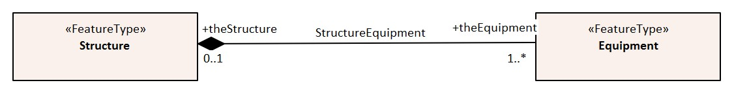
Figure 4-3 – Composition

Information types
Details of information types can be found in Annex A – Data Classification and Encoding Guide, clauses 2.3.1, 2.3.3 and Section 24.

Spatial quality
Spatial quality attributes are carried in an information class called Spatial Quality. Details of spatial quality can be found in Annex A – Data Classification and Encoding Guide, clauses 2.3.3 and 24.5.

Information relationships
An information relationship links instances of an information type with instances of a feature type, spatial object, or information type. Just as with feature relationships, the relationship may take the form of an association, aggregation, or composition.

Information association
An information association is used to describe a relationship between a feature type, spatial object, or information type on one side and an information type on the other side.
EXAMPLE: A Nautical Information information type provides additional information to any geo feature using an information association called additional information.
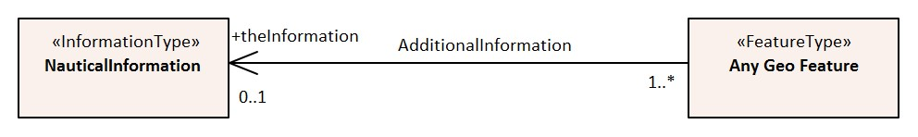
Figure 4-4 – Information association

Spatial associations
The information association “Spatial association” provides the binding between spatial objects and spatial quality. It is noted here because the S-100 Feature Catalogue model is incapable of describing this relationship.
Any spatial type other than surface may be associated with spatial quality (no use case for associating surfaces with spatial quality attributes has been identified). Vertical uncertainty is prohibited for curves as this dimension is not supported by curves.

Attributes
S-101 defines attributes as either simple or complex.

Simple attributes
S-101 uses nine types of simple attributes; these types are listed in Annex A – Data Classification and Encoding Guide, clause 2.4.2. Descriptions of the simple attributes included in S-101 can be found in Annex A, Sections 27, 28 and 30.

Complex attributes
Complex attributes are aggregations of other attributes that are either simple or complex. The aggregation is defined by means of attribute bindings. Examples of modelling complex attributes can be found in S-100 Part 2a, Appendix 2a-A. Descriptions of the complex attributes included in S-101 can be found in Annex A – Data Classification and Encoding Guide, Section 29.

Attribute suppression
The S-100 XML Feature Catalogue Schema allows for attributes to be suppressed in the end-user system Pick Report using the attribute attributeVisibility for the class S100_FC_AttributeBinding (see S-100 Part 5, Appendix 5-A, Tables 5-A-16 and 5-A-21) . These attributes are generally used to assist with optimum display of features in ECDIS systems; or to perform other administrative roles. For S-101, these attributes are identified in the Feature Catalogue by population of attributeVisibility value “privateVisibility”.
The following is the list of S-101 attributes that will be suppressed in the ECDIS Pick Report:
default clearance depth display priority drawing index
drawing instruction file locator flare bearing
in the water interoperability identifier major light
name usage sector arc extension sector line length
surrounding depth

Feature Object Identifier
Each real world feature within an ENC must have a unique universal Feature Object Identifier. This identifier is formed by the binary concatenation of the contents of the subfields of the “Feature Object Identifier” [FOID] field. Information types must not have a FOID.
The FOID may be used to identify that the same feature has instances in separate datasets. For example, the same feature included in different optimum display scale datasets or a feature being split by the ENC dataset limits within the same optimum display scale.
FOIDs must not be repeated in a dataset. Where a real-world feature has multiple parts within a single ENC dataset due to ENC dataset limit truncations, the feature will reference each spatial part of the feature within the dataset. This is accomplished in the ISO/IEC 8211 encoding by including a Spatial Association for each disjoint component. When a feature’s geometry is split each component must be represented by a separate spatial feature that the feature refers to.
Where a real-world feature is repeated in multiple datasets of different optimum display scale, the FOID should be repeated for each instance of the feature. Where this occurs, all instances of the geo feature must be identical, that is same feature class and attribute values.

Dataset

Introduction
A dataset is a grouping of features, attributes, geometry and metadata which comprises a specific coverage.

Dataset rules
In order to facilitate the efficient processing of ENC data the geographic coverage of a given optimum display scale may be split into multiple datasets (see clause 4.5.4).
The discovery metadata of a dataset must list all the Data Coverage features contained within that dataset and their assigned scale attributions.
An ENC update dataset must not change the limit of a Data Coverage feature for the base ENC dataset. Where the limit of a Data Coverage feature for a base ENC dataset is to be changed, this must be done by issuing a New Edition of the dataset.
A dataset must not cross the 180° meridian.

Data Coverage rules
- All base datasets (new dataset, new edition and re-issue) must contain at least one Data Coverage feature.
- The data boundary of the base dataset is defined by the extent of the Data Coverage features and must be contained within the bounding box.
- Data Coverage features from different datasets covering the same geographical area must have non-overlapping display scale ranges (see clause 4.6). The scale ranges should, as much as possible, be continuous.
[Exception: At areas of agreed national data limits, where, if it is difficult to achieve a perfect join, an overlapping buffer zone of up to 5 metres may be used. For this situation, there must be no gaps in data between the adjoining datasets.]
Data Producers should develop consistent S-101 ENC schemes carefully and try to avoid complex situations, using a regional approach where possible.
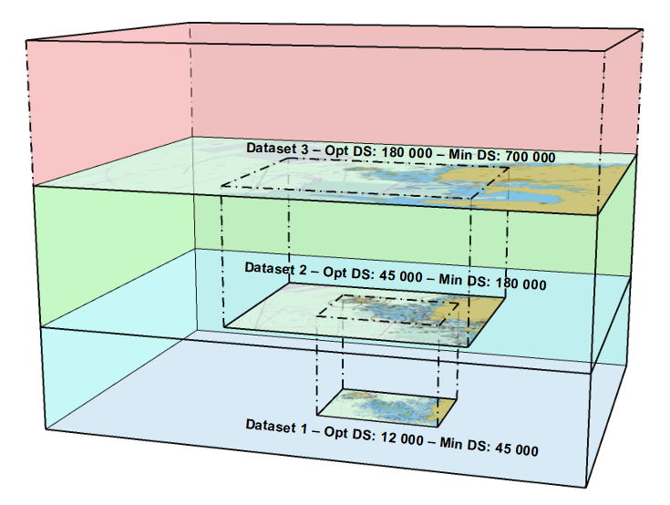
Figure 4-5 – Example of Datasets with single Data Coverage feature
- When a dataset has multiple Data Coverage features:
  - The minimum display scales must all be the same
  - The drawing indexes*, where populated, must be the same.
  - The optimum display scales may be different; and
  - The maximum display scales may be different.
- When a dataset has multiple Data Coverage features then the optimum display scale of the dataset (as defined in the “dataCoverage” field of the “S100_DatasetDiscoveryMetadata” – see clauses 12.1.2 and 12.1.2.2) must be equal to the largest optimum display scale of the Data Coverage features. When a dataset has multiple Data Coverage features then the maximum display scale of the dataset as defined in the “S100_DatasetDiscoveryMetadata” must be set to an empty (null) value.
* The attribute drawing index is required where the datasets intended to form a seamless presentation in ECDIS do not share a common minimum display scale. The attribute drawing index is also required if the dataset may need to form a seamless presentation with one or more S-57 datasets, in which case the value should correspond to the usage band of the adjoining or overlapping S-57 dataset(s). See S-101 Annex A – Data Classification and Encoding Guide, clauses 3.5 and 28.3.
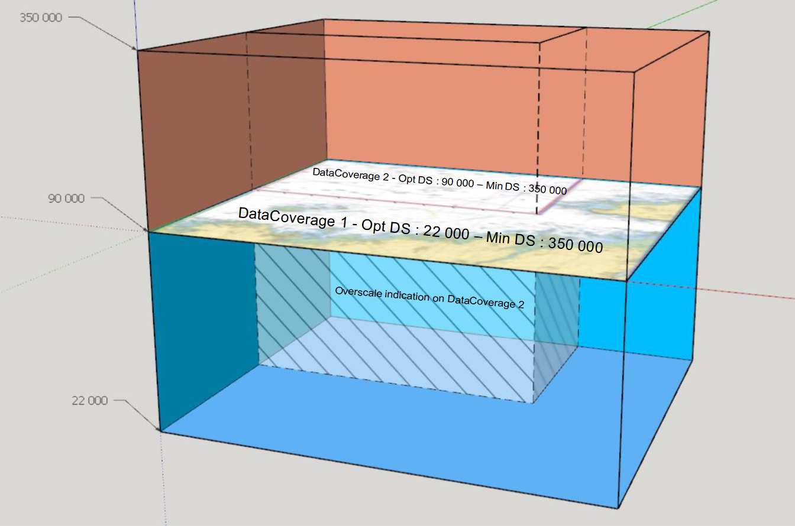
Figure 4-6 – Dataset with multiple Data Coverage features

Dataset size

Datasets must not exceed 10 MB.
Update datasets should not normally be larger than 50 kb and must not be larger than 300 kb.

Display scale range
A scale range of a dataset is used to indicate a range of scales between which a producer considers the data is intended for use. (See clause 4.7 for how datasets are to be loaded and unloaded within a navigation system.) The smallest scale is defined by the minimum display scale and the largest scale by the optimum display scale. The maximum display scale indicates the scale that the Data Producer considers that the “grossly overscaled” warning should be triggered. The values for minimum display scale and optimum display scale must be set at one of the scales specified in clause 3 (spatial resolutions); the attribute maximum display scale can be set to any value. See also S-101 Annex A – Data Classification and Encoding Guide, clause 3.5.
There must not be overlapping scale ranges (that is, overlaps between values of optimum display scale and minimum display scale) between datasets covering the same geographical area.
When the mariner’s selected viewing scale (MSVS) is smaller than the value indicated by minimum display scale, features within the Data Coverage feature are not displayed, except where the System Database does not contain a dataset covering the area at a smaller scale, in which case the dataset will be continuously displayed.
When the MSVS is larger than the value indicated by optimum display scale, the overscale indication, in the form of an overscale factor covering the area that is overscale, must be shown. When at own ship’s position a dataset with a larger optimum display scale than the MSVS is available, an indication is required and must be shown on the same screen as the chart display.
When the MSVS is larger than the value indicated by maximum display scale, the overscale indication, in the form of an overscale factor and, additionally, a pattern covering areas that are overscale, must be shown to indicate that the data is “grossly overscaled” in accordance with the requirement defined in S-98 Main document, clause 12.3.3.
Within ENC schemes it is preferable that the scale ranges for different datasets covering the same geographical area to be continuous (see clause 4.5.3). However, where the scale ranges are non-continuous, the ECDIS will display the larger scale dataset until the MSVS is equal to or at smaller scale than the optimum display scale of the next smaller scale dataset.

Dataset loading and display order
New algorithms for dataset loading and unloading; and rendering (display) within a navigation system are prescribed in S-101 in order for the appropriate ENC to be viewed at the mariner’s selected viewing scale. This will simplify the process for navigation systems, giving clear and concise rules on how and when data is loaded and unloaded; and the order at which datasets are to be displayed. The concept of navigation purpose is restricted for use in presenting ENCs in a visual catalogue and must not be used for determining which dataset should be displayed.
Details of the dataset loading and data display algorithms are available in S-98 Appendix E – Dataset Loading and Display (Rendering) Algorithms.
Note 1: The algorithms only address loading and display related to visualization within the system graphics window. The application may need to load other datasets to satisfy requirements related to alerts processing, such as MSC.530(106) A11.2.
Note 2: Light sectors. It should be possible, on request, for the mariner to be capable of identifying the colour of the sectors affecting the ship, even if the lights involved are off the display.

Dataset loading algorithm (dataset selection)
See S-98 Appendix E – Dataset Loading and Display (Rendering) Algorithms.

Dataset display order (dataset rendering)
See S-98 Appendix E – Dataset Loading and Display (Rendering) Algorithms.
Figures 4-7 to 4-10 below are intended to assist in understanding how the datasets should be displayed in the system graphics window:
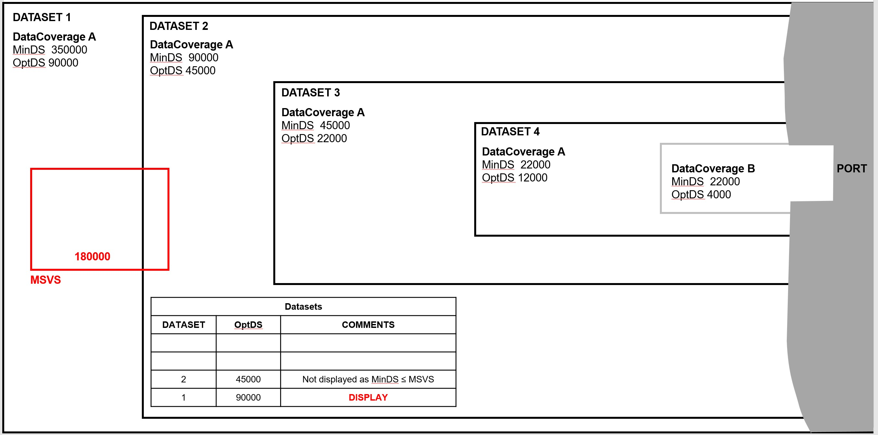
Figure 4-7 – Dataset loading – scenario 1
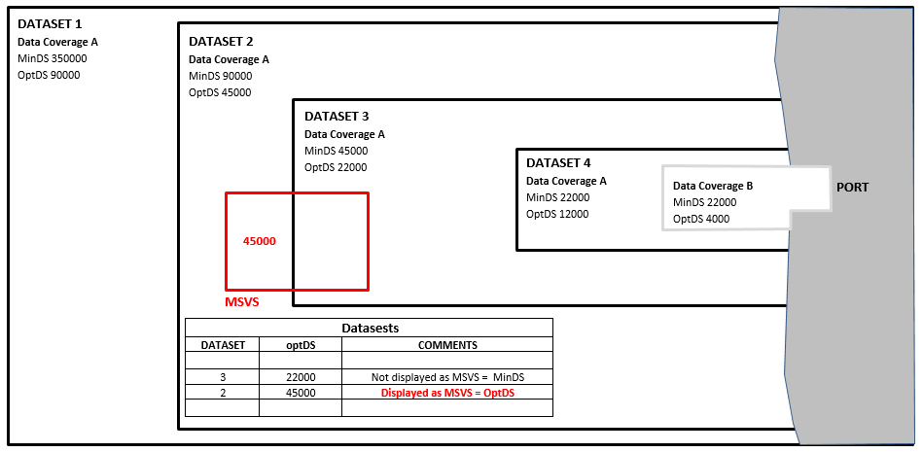
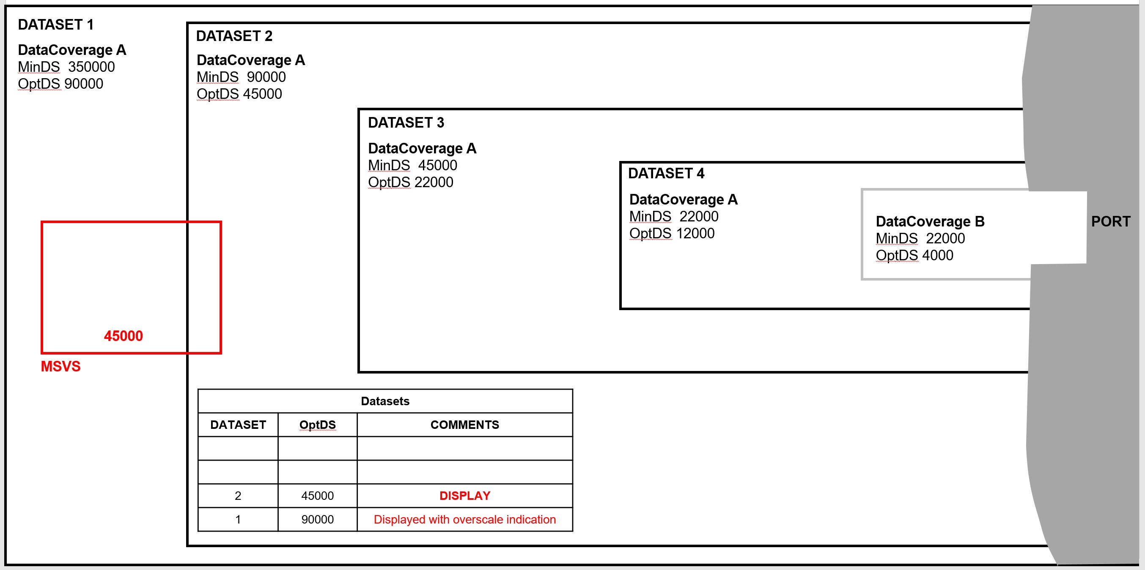
Figure 4-8 – Dataset loading – scenario 2
Figure 4-9 – Dataset loading – scenario 3

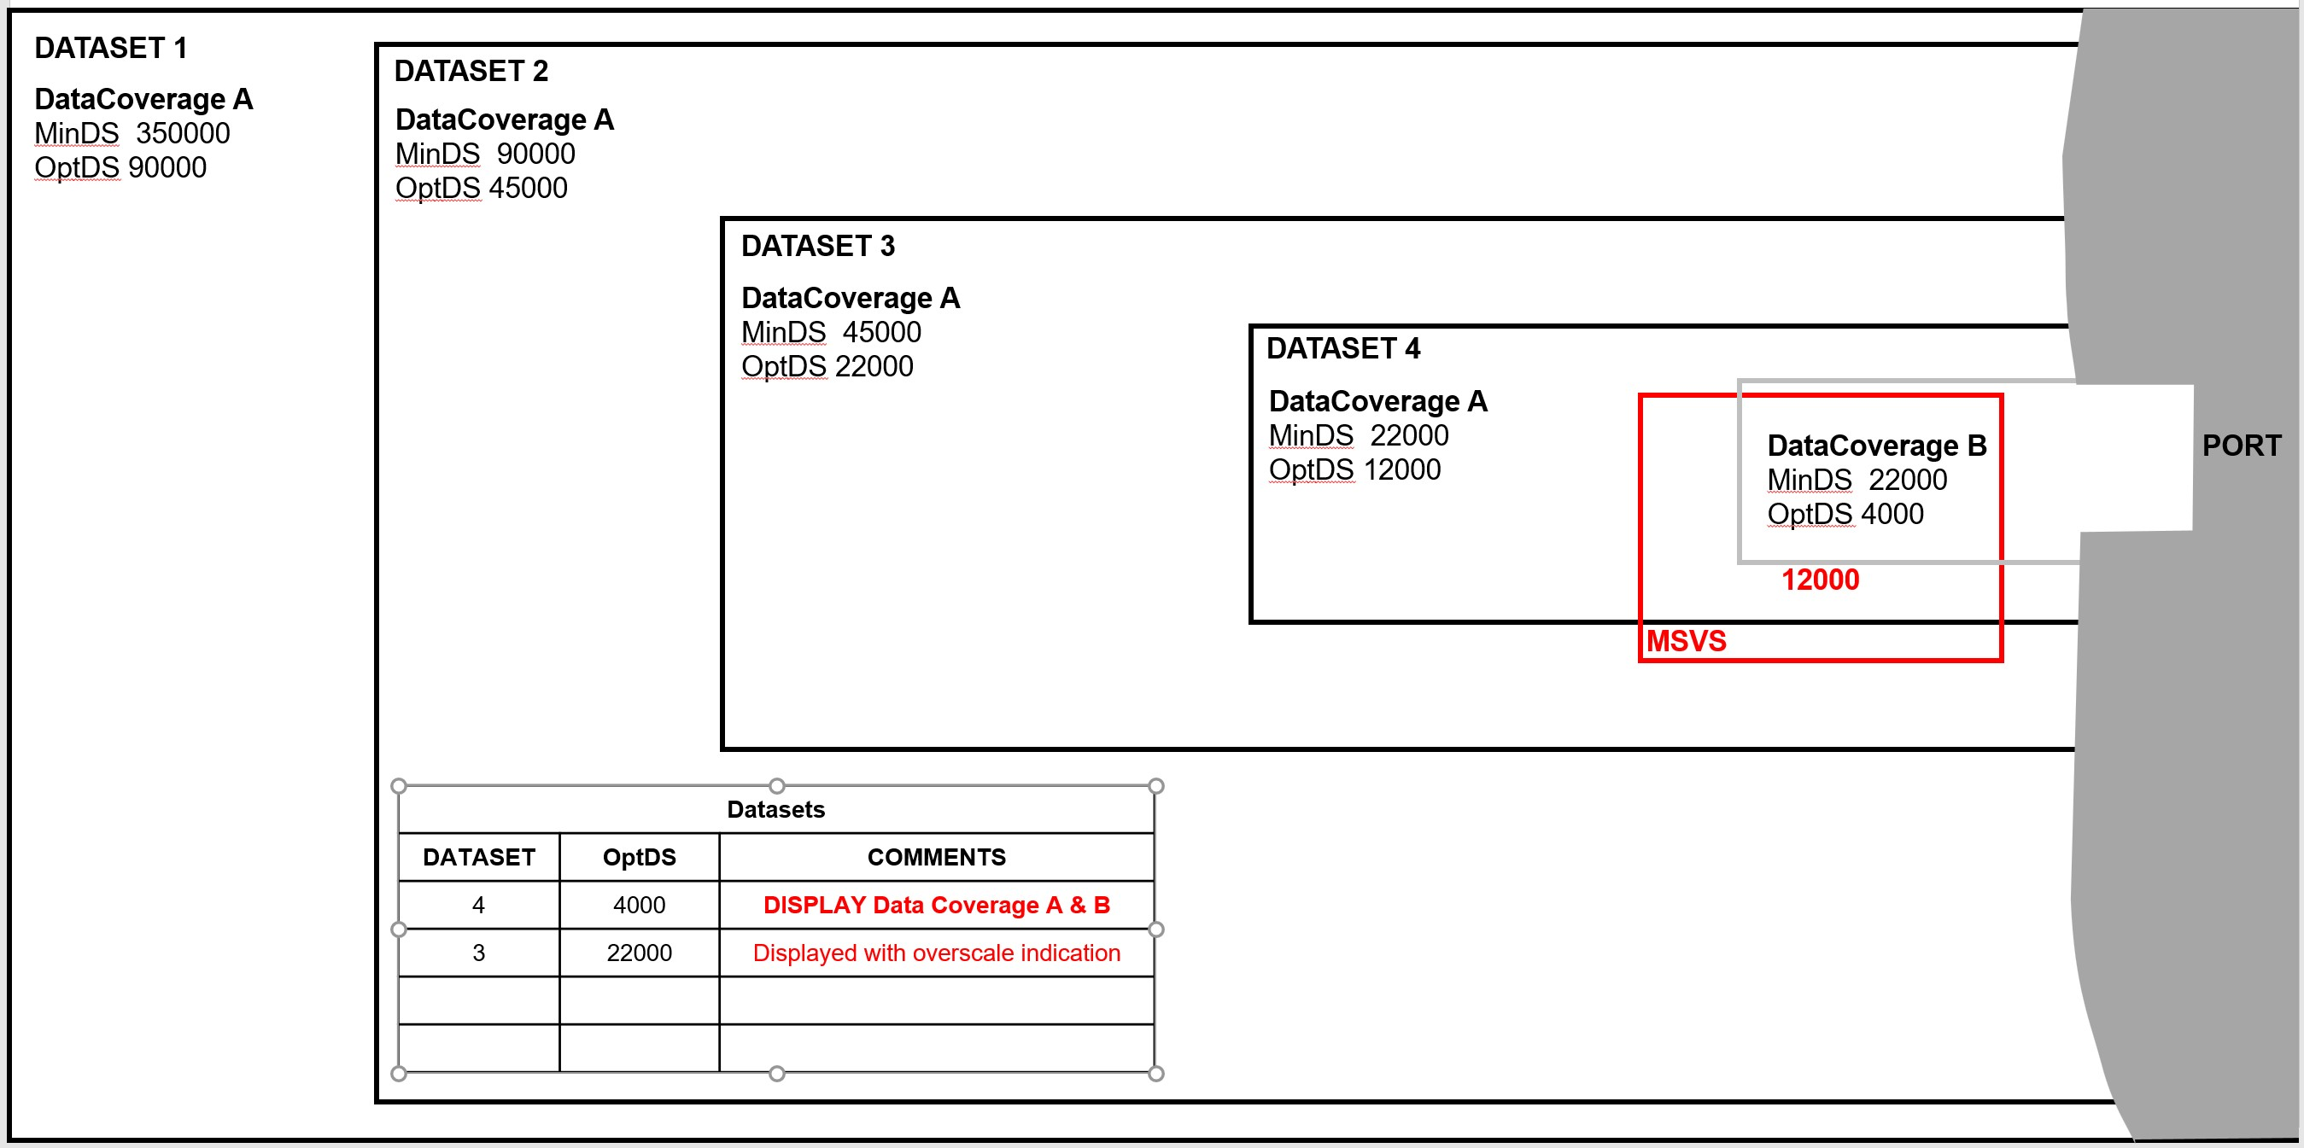
Figure 4-10 – Dataset loading – scenario 4

Geometry

S-100 level 3a geometry
The underlying geometry of an ENC is constrained to level 3a which supports 0, 1 and 2 dimensional features (points, curves and surfaces) as defined by S-100 Part 7 – Spatial Schema.
Level 3a is described by the following constraints:
- Each curve must reference a start and end point (they may be the same).
- Curves must not self intersect. See Figure 4-11.
- Areas are represented by a closed loop of curves beginning and ending at a common point.
- In the case of areas with holes, all internal boundaries must be completely contained within the external boundary and the internal boundaries must not intersect each other or the external boundary. Internal boundaries may touch other internal boundaries or the external boundary tangentially (that is at one point) as shown in Figure 4-12.
- The outer boundary of a surface must be in a clockwise direction (surface to the right of the curve) and the curve orientation positive. The inner boundary of a surface must be in a counter-clockwise direction (surface to the right of the curve) and the curve orientation negative. See Figure 4-13.
S-101 further constrains Level 3a with the following:
- Coincident linear geometry must be avoided when there is a dependency between features.
- The interpolation of GM_CurveSegment must be loxodromic.
- Linear geometry is defined by curves which are made of curve segments. Each curve segment contains the geographic coordinates as control points and defines an interpolation method between them. The distance between two consecutive control points must not be less than 0.3 mm at the optimum display scale of the data.
- A feature may reference multiple geometries but must only reference geometries of a single geometric primitive (point, pointset, curve or surface).
The following exception applies to S-101:
- The use of coordinates is restricted to two dimensions, except in the case of features encoded using GM_Point (point) and GM_Multipoint (pointSet) which may have three dimensional coordinates.
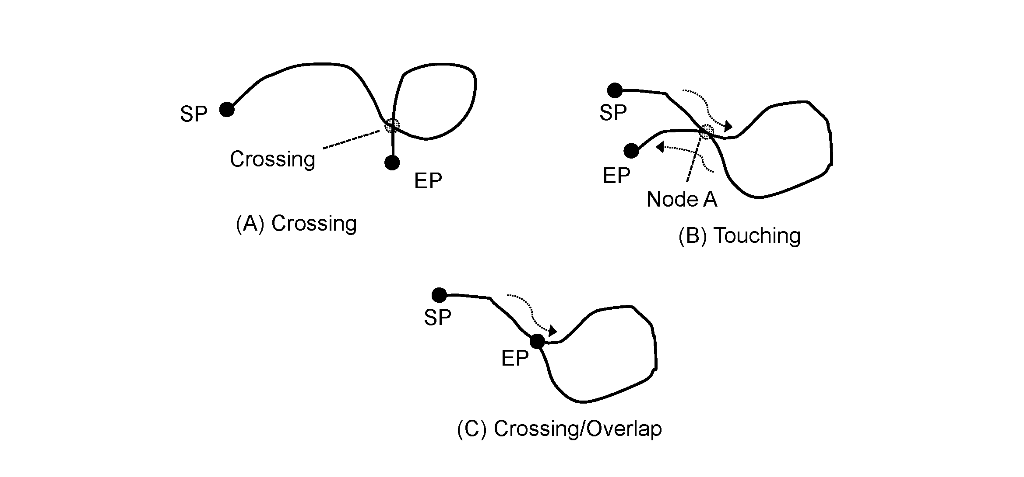
Figure 4-11 – Self intersect examples

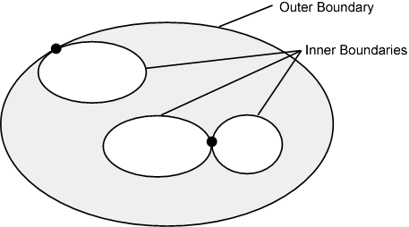
Figure 4-12 – Area Holes

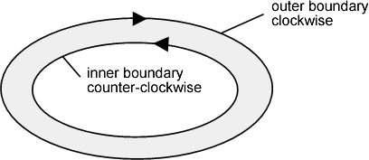
Figure 4-13 – Boundary direction

Use of scale properties for feature to geometry relations
The attributes scaleMinimum and scaleMaximum of class S100_GF_SpatialAttributeType are not used. Therefore, the encoding must always encode the values ‘Not Applicable’.
Scale dependent depiction for the end user system is controlled by the thematic attribute scale minimum for the feature type only.

Masking
In certain circumstances, the symbolisation of a curve may need to be suppressed. This is done using the Masked Spatial Type [MASK] field of the Feature Type record. The Mask Update Instruction [MUIN] must be set to {1} and Referenced Record Name [RRNM] and Referenced Record Identifier [RRID] fields must be populated with the values of the referenced spatial record. The Mask Indicator [MIND] subfield must be set to either {1} or {2} (see Annex B – clause B-5.1.33).
Figure 4-14 is an example without masking and Figure 4-15 is an example of a masked edge between River and Depth Area features, where the seaward edge of the River should be masked. In this example MIND is set to {2} – suppress portrayal.
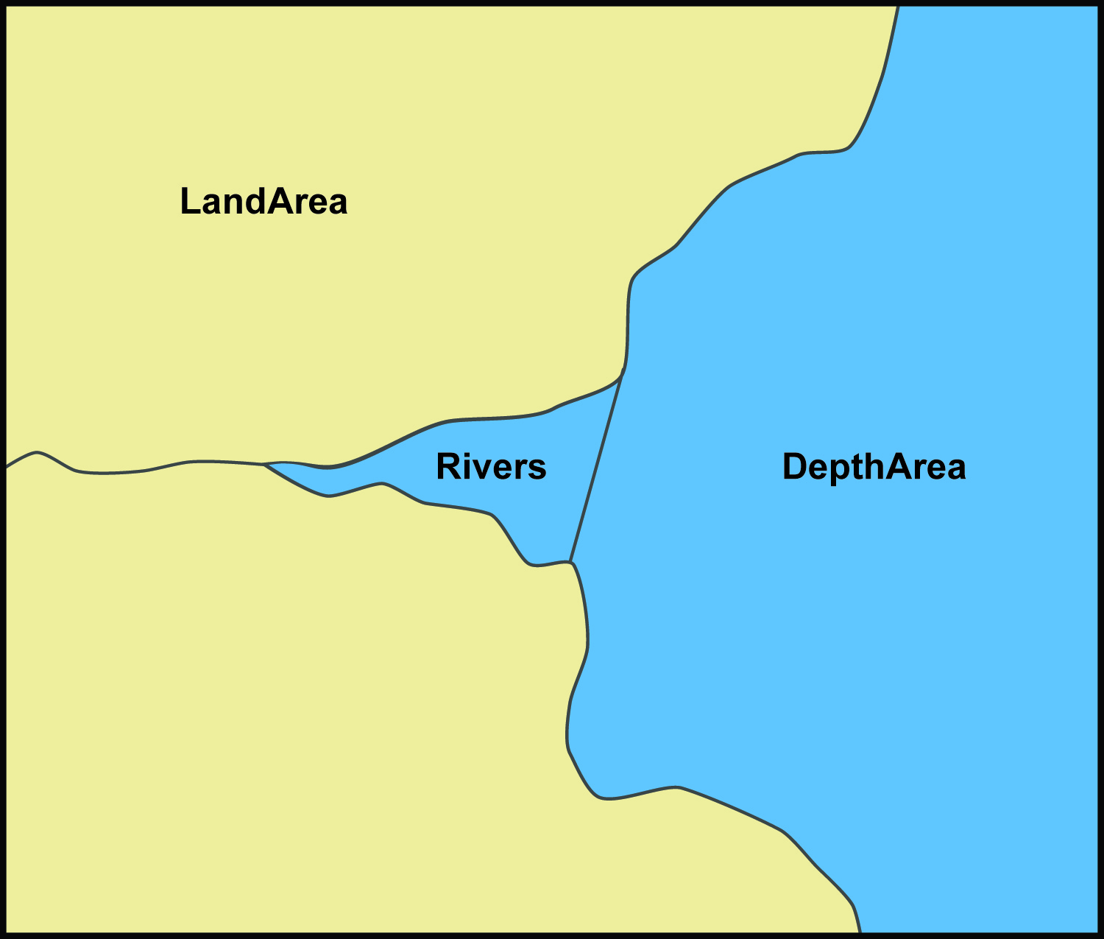
Figure 4-14 – Example without masking
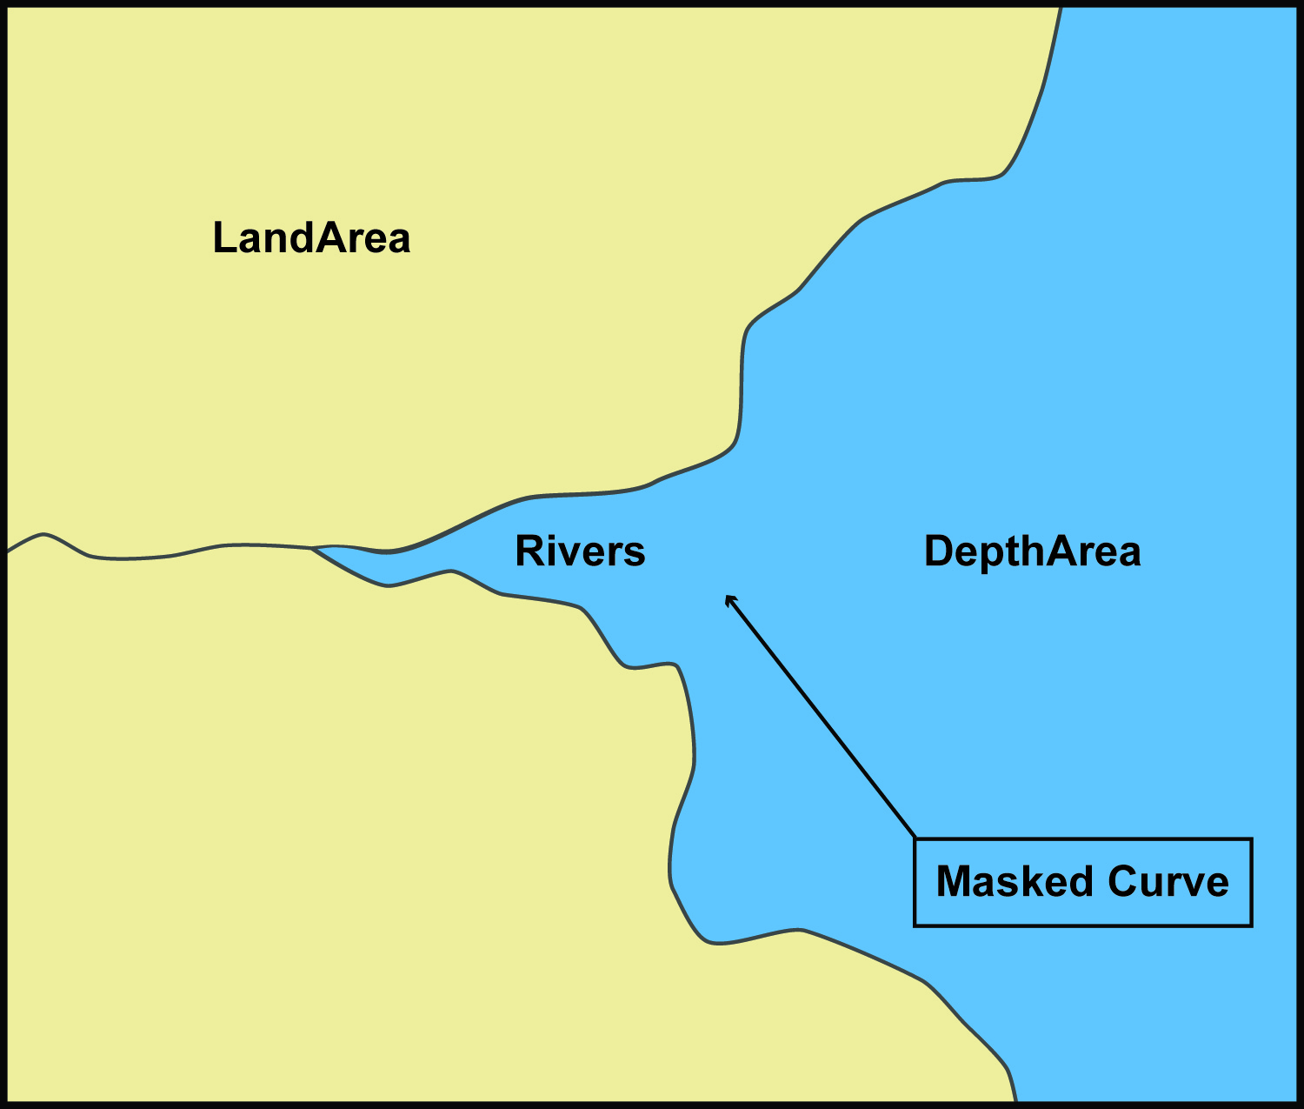
Figure 4-15 – Example with masking

Coordinate Reference Systems (CRS)

Introduction
An ENC dataset must define at least one compound CRS, which must be composed of one geodetic CRS and one vertical CRS. All compound CRSs within the same dataset must use the same geodetic CRS.
NOTE: The vertical CRS described in clause 5.3 below does not apply to depths, heights, elevations and vertical clearances where the information is encoded as an attribute rather than the vertical component (Z-coordinate) of the CRS. This vertical datum information is included in the ENC dataset using the meta features Sounding Datum and Vertical Datum of Data. See S-101 Annex A – Data Classification and Encoding Guide clauses 3.9 and 3.10.

Horizontal Coordinate Reference System
For ENC the horizontal CRS must be EPSG:4326 (WGS84). The full reference to EPSG:4326 can be found at www.epsg-registry.org.
Horizontal Coordinate Reference System: EPSG:4326 (WGS84)
Projection: None
Temporal reference system: Gregorian calendar
Coordinate Reference System registry: EPSG Geodetic Parameter Registry
Date type (according to ISO 19115): 002- publication
Responsible party: International Organisation of Oil and Gas Producers (IOGP)
URL: http://www.iogp.org

Vertical CRS for Soundings
For ENC the vertical CRS must be in metres and is only relevant to soundings (S-101 features Sounding and Depth – No Bottom Found, see S-101 Annex A – Data Classification and Encoding Guide clause 3.9), where the depth information is stored in the Z-coordinate. Depths are represented by positive values, while negative values indicate intertidal (drying) soundings.
Although all coordinates in a dataset must refer to the same geodetic CRS, different Vertical Datums can be used for the depth component of a coordinate tuple. Therefore the vertical CRS can be repeated. For each vertical CRS a unique identifier is defined. Those identifiers will be used to indicate which Vertical CRS is used.
The encoding for the Coordinate Reference System record fields can be found at Annex B, clauses B-5.1.9 to B-5.1.12; and is demonstrated with the following examples. The example at Table 5-1 specifies a compound CRS. The first component is a 2D Geographic CRS (WGS84). The second component is a Vertical CRS for depth using the Vertical Datum: Lowest Astronomical Tide.
Table 5-1 – Compound CRS (WGS84 and Lowest Astronomical Tide)
Field | Subfield | Value | Description
CSID |  |  | Coordinate Reference System Record Identifier
 | RCNM | 15 | Record Name (15 = Coordinate Reference System Identifier)
 | RCID | 1 | Record Identification Number
 | NCRC | 2 | Number of CRS Components
CRSH |  |  | Coordinate Reference System Header
 | CRIX | 1 | CRS Index
 | CRST | 1 | CRS Type (1 = 2D Geographic)
 | CSTY | 1 | Coordinate System Type (1 = Ellipsoidal CS)
 | CRNM | WGS84 | CRS Name
 | CRSI | 4326 | CRS Identifier
 | CRSS | 2 | CRS Source (2 = EPSG)
 | SCRI |  | CRS Source Information (omitted)
CRSH |  |  | Coordinate Reference System Header
 | CRIX | 2 | CRS Index
 | CRST | 5 | CRS Type (5 = Vertical)
 | CSTY | 3 | Coordinate System Type (3 = Vertical)
 | CRNM | lowest astronomical tide | CRS Name
 | CRSI |  | CRS Identifier (omitted)
 | CRSS | 255 | CRS Source (255 = Not Applicable)
 | SCRI |  | CRS Source Information (omitted)
CSAX |  |  | Coordinate System Axes
 | AXTY | 12 | Axis Type (12 = Gravity Related Depth)
 | AXUM | 4 | Axis Unit of Measure (4 = Metres)
VDAT |  |  | Vertical Datum
 | DTNM | lowest astronomical tide | Datum Name
 | DTID | 23 | Datum Identifier (23 = Lowest Astronomical Tide)
 | DTSR | 2 | Datum Source (2 = Feature Catalogue)
 | SCRI |  | Datum Source Information (omitted)

The example at Table 5-2 is similar to the above except that its second component is encoded with the Vertical Datum: Mean Sea Level.
Table 5-2 – Compound CRS (WGS84 and Mean Sea Level)
Field | Subfield | Value | Description
CSID |  |  | Coordinate Reference System Record Identifier
 | RCNM | 15 | Record Name (15 = Coordinate Reference System Identifier)
 | RCID | 1 | Record Identification Number
 | NCRC | 2 | Number of CRS Components
CRSH |  |  | Coordinate Reference System Header
 | CRIX | 1 | CRS Index
 | CRST | 1 | CRS Type (1 = 2D Geographic)
 | CSTY | 1 | Coordinate System Type (1 = Ellipsoidal CS)
 | CRNM | WGS84 | CRS Name
 | CRSI | 4326 | CRS Identifier
 | CRSS | 2 | CRS Source (2 = EPSG)
 | SCRI |  | CRS Source Information (omitted)
CRSH |  |  | Coordinate Reference System Header
 | CRIX | 2 | CRS Index
 | CRST | 5 | CRS Type (5 = Vertical)
 | CSTY | 3 | Coordinate System Type (3 = Vertical)
 | CRNM | mean sea level | CRS Name
 | CRSI |  | CRS Identifier (omitted)
 | CRSS | 255 | CRS Source (255 = Not Applicable)
 | SCRI |  | CRS Source Information (omitted)
CSAX |  |  | Coordinate System Axes
 | AXTY | 12 | Axis Type (12 = Gravity Related Depth)
 | AXUM | 4 | Axis Unit of Measure (4 = Metres)
VDAT |  |  | Vertical Datum
 | DTNM | mean sea level | Datum Name
 | DTID | 3 | Datum Identifier (3 = Mean Sea Level)
 | DTSR | 2 | Datum Source (2 = Feature Catalogue)
 | SCRI |  | Datum Source Information (omitted)

NOTE: For S-101, the vertical CRS encoded in the Coordinate Reference System record fields for soundings is not utilized by the ECDIS in conveying the sounding datum information for an ENC to the Mariner in ECDIS. This information is provided instead using the S-101 meta feature Sounding Datum (see S-101 Annex A – Data Classification and Encoding Guide, clause 3.9).

Data Quality

Introduction
Data quality allows users and user systems to assess fitness for use of the provided data. Data quality measures and the associated evaluation are reported as metadata of a data product. This metadata improves interoperability with other data products and provides scope for usage by user groups that the data product was not originally intended for. The secondary users can make assessments of the data product usefulness in their application based on the reported data quality measures.
For S-101 the following data quality elements have been included:
- Conformance to this Product Specification;
- Intended purpose of the data product;
- Completeness of the data product in terms of coverage;
- Logical consistency;
- Depth uncertainty and accuracy;
- Positional uncertainty and accuracy;
- Thematic accuracy;
- Temporal quality;
- Aggregation measures;
- Validation checks or conformance checks including:
- General tests for dataset integrity; and
- Specific tests for compliance against the S-101 data model.
In addition to conformance to the Data Quality elements detailed in clause 6.2 below, additional quantitative information may be provided to the user using relevant metadata features and attribution. The hierarchy of metadata provided in S-101 Annex A – Data Classification and Encoding Guide at Table 3-1 in clause 3.3 describes this further. For S-101 it is not relevant to provide a Data Quality Report to end users.

Completeness

Commission
Commission is applicable for S-101. Data Producers must verify that no excess items have been included in the dataset. This includes duplicate items, which must be removed.
IHO Publications S-158:100 – S-100 Validation Checks and/or S-158:101 – S-101 Validation Checks, include data validation check(s) intended to identify excess and/or duplicate items.
If no excess or duplicate items are present the dataset PASSES this test.

Omission
Omission is applicable for S-101. Data Producers must verify that no items that should have been included in the dataset have been missed. This includes missing features specified as mandatory in S-101; and missing ENC support files referenced by the dataset.
IHO Publications S-158:100 – S-100 Validation Checks and/or S-158:101 – S-101 Validation Checks, include data validation check(s) intended to detect missing items.
If no items have been omitted the dataset PASSES this test.

Logical consistency

Conceptual consistency
Conceptual Consistency is applicable for S-101 and follows the guidelines from S-100 Part 1.
Data Producers must verify that the dataset conforms to the S-100 General Feature Model. IHO Publications S-158:100 – S-100 Validation Checks and/or S-158:101 – S-101 Validation Checks, provide validation checks which verify this conformance.
If no conceptual consistency checks classified as Critical in S-158:100 or S-158:101 are reported the dataset PASSES this test.

Domain consistency
Domain consistency is applicable for S-101 and follows the guidelines from S-100 Part 5.
Data Producers must verify that the dataset conforms to the S-101 Feature Catalogue and rules described in S-101 Annex A – Data Classification and Encoding Guide. IHO Publications S-158:100 – S-100 Validation Checks and/or S-158:101 – S-101 Validation Checks, provide validation checks which verify this conformance.
If no domain consistency checks classified as Critical in S-158:100 or S-158:101 are reported the dataset PASSES this test.

Format consistency
Format Consistency is applicable for S-101 and follows the guidelines from S-100 Part 10a.
Data Producers must verify that the dataset conforms to S-101 Annex B – Data Product format (encoding). IHO Publications S-158:100 – S-100 Validation Checks and/or S-158:101 – S-101 Validation Checks, provide validation checks which verify this conformance.
If no format consistency checks classified as Critical in S-158:100 or S-158:101 are reported the dataset PASSES this test.

Topological consistency
Topological consistency is applicable for S-101 and follows the guidelines from S-100 Part 7.
Data Producers must verify that the dataset conforms to the requirements for topology set out in Section 4 of this document. IHO Publications S-158:100 – S-100 Validation Checks and/or S-158:101 – S-101 Validation Checks, provide validation checks which verify this conformance.
If no topological consistency checks classified as Critical in S-158:100 or S-158:101 are reported the dataset PASSES this test.

Positional uncertainty and accuracy

Absolute or external accuracy
Absolute or external accuracy is applicable for S-101 and follows the guidelines from S-100 Part 4c.
Data Producers must verify the absolute accuracy of S-101 datasets and ensure that they achieve an adequate accuracy. Additionally the relevant metadata features and attributes as described in S-101 Annex A – Data Classification and Encoding Guide, must be populated where applicable.

Vertical position accuracy
Vertical position accuracy is applicable for S-101 and follows the guidelines from S-100 Part 4c.
Data Producers must verify the vertical position accuracy of S-101 datasets and ensure that they achieve an adequate accuracy. The relevant metadata features and attributes as described in S-101 Annex A – Data Classification and Encoding Guide, should be populated to reflect the vertical position accuracy.

Horizontal position accuracy
Horizontal position accuracy is applicable for S-101 and follows the guidelines from S-100 Part 4c.
Data Producers must verify the horizontal position accuracy of S-101 datasets and ensure that they achieve an adequate accuracy. The relevant metadata features and attributes as described in S-101 Annex A – Data Classification and Encoding Guide, should be populated to reflect the horizontal position accuracy.

Relative or internal accuracy
Relative or internal accuracy is applicable for S-101 and follows the guidelines from S-100 Part 4c.
Data Producers must verify the relative or internal accuracy of S-101 datasets and ensure that they achieve an adequate accuracy.

Gridded data positional accuracy
Gridded data positional accuracy is not applicable for S-101.

Thematic accuracy

Thematic classification correctness
Thematic classification correctness is applicable for S-101 and follows the guidelines from S-100 Part 4c.
Data Producers must verify that features have been encoded correctly when included in the S-101 dataset. Encoded features must conform to the S-101 Feature Catalogue and the rules described in the S-101 Annex A – Data Classification and Encoding Guide. IHO Publications S-158:100 – S-100 Validation Checks and/or S-158:101 – S-101 Validation Checks, provide validation checks which verify this conformance.
If no thematic classification correctness checks classified as Critical in S-158:100 or S-158:101 are reported the dataset PASSES this test.

Non-quantitative attribute accuracy
Non-quantitative attribute accuracy is applicable for S-101 and follows the guidelines from S-100 Part 4c.
Data Producers must verify that non-quantitative attributes have been populated correctly when included in the S-101 dataset. Non-quantitative attributes must conform to the S-101 Feature Catalogue and the rules described in the S-101 Annex A – Data Classification and Encoding Guide. IHO Publications S-158:100 – S-100 Validation Checks and/or S-158:101 – S-101 Validation Checks, provide validation checks which verify this conformance.
If no non-quantitative attribute checks classified as Critical in S-158:100 or S-158:101 are reported the dataset PASSES this test.

Quantitative attribute accuracy
Quantitative attribute accuracy is applicable for S-101 and follows the guidelines from S-100 Part 4c.
Data Producers must verify that quantitative attributes have been populated correctly when included in the S-101 dataset. Quantitative attributes must conform to the S-101 Feature Catalogue and the rules described in the S-101 Annex A – Data Classification and Encoding Guide. Relevant metadata features and attributes must be used to indicate the accuracy where applicable. IHO Publications S-158:100 – S-100 Validation Checks and/or S-158:101 – S-101 Validation Checks, provide validation checks which verify this conformance.
If no quantitative attribute checks classified as Critical in S-158:100 or S-158:101 are reported the dataset PASSES this test.

Temporal quality

Temporal consistency
Temporal consistency is applicable for S-101 and follows the guidelines from S-100 Part 4c.
Data Producers must verify that the dataset conforms to rules described in the S-101 Annex A – Data Classification and Encoding Guide. IHO Publications S-158:100 – S-100 Validation Checks and/or S-158:101 – S-101 Validation Checks, provide validation checks which verify this conformance.
If no temporal consistency checks classified as Critical in S-158:100 or S-158:101 are reported the dataset PASSES this test.

Temporal validity
Temporal validity is applicable for S-101 and follows the guidelines from S-100 Part 4c.
Data Producers must verify that the dataset conforms to rules described in the S-101 Annex A – Data Classification and Encoding Guide. IHO Publications S-158:100 – S-100 Validation Checks and/or S-158:101 – S-101 Validation Checks, provide validation checks which verify this conformance.
If no temporal validity checks classified as Critical in S-158:100 or S-158:101 are reported the dataset PASSES this test.

Temporal accuracy
Temporal accuracy is applicable for S-101 and follows the guidelines from S-100 Part 4c.
The Data Producer must verify the temporal accuracy of the S-101 dataset.

Aggregation
Aggregation is applicable for S-101. The aggregated data quality result provides a result if the dataset has passed conformance to the Product Specification.
Data Producers must ensure that all applicable data quality aspects are checked and only if all of these checks are PASSED can the dataset be considered a valid S-101 dataset. This is indicated by the Data Producer signing the dataset.

Data compliance and usability
All S-101 datasets must be validated against the above data quality elements using conformance checks that are located in IHO Publications S-158:100 – S-100 Validation Checks and/or S-158:101 – S-101 Validation Checks. As a minimum requirement, all datasets must conform to all checks that are categorized as “Critical” in S-158:100 and S-158:101.
S-101 datasets must conform to all mandatory elements of Annex A – Data Classification and Encoding Guide, where the word ‘must’ is used.
In addition to the above, dataset usability must be assessed against:
- Intended user requirements in regard to coverage, scale and specific content requirements as defined by the Producing Agency and key stakeholders;
- Conformance to established maintenance processes (see Section 8 below); and
- Overall compliance with the S-101 Product Specification, including context-specific evaluation of individual encoding instances for requirement of conformance to checks classified as “Error” and “Warning” in S-158:100 and S-158:101.
For dataset integrity requirements, see clause 11.6.

Data Capture and Classification
The S-101 ENC Data Classification and Encoding Guide (DCEG) describes how data describing the real world should be captured using the types defined in the S-101 Feature Catalogue. This Guide is located at Annex A.

Maintenance

Introduction
This clause describes the requirement to adequately maintain datasets; use of newly acquired source data; maintenance requirements within the overall production process; and how Feature and Portrayal Catalogues are to be managed within an S-100 based marine navigation system.

Maintenance and update frequency
Datasets must be maintained as needed; and the overall production process must include mechanisms for ENC updating designed to meet the needs of the mariner regarding safety of navigation.

Data source
Data Producers must use all available and applicable sources, as evaluated against a robust data assessment process, to maintain and update ENC datasets as required.

Production process
Data Producers should follow their established production processes for maintaining and updating datasets. Data must be maintained against S-101 Annex A – Data Classification and Encoding Guide, checked against IHO Publications S-158:100 – S-100 Validation Checks and S-158:101 – S-101 Validation Checks, and encapsulated in ISO/IEC 8211.
Only maintained datasets that conform to the mandatory requirements outlined in S-101 will be considered to be an ENC satisfying the SOLAS chart carriage requirements for use in an ECDIS.

Feature and Portrayal Catalogue management
For each new version of the S-101 Product Specification a new Feature and/or Portrayal Catalogue may be released. The management of Feature and Portrayal Catalogues in end user systems is described in IHO Publication S-98 – S-100 ECDIS and Interoperability Specification.

Portrayal

Introduction
S-101 portrayal is intended to contribute to the safe operation of an S-100 based marine navigation system by:
- Ensuring base and supplementary levels of display for ENC data; standards of symbols, colours and their standardized assignment to features; scale limitations of data presentation; and appropriate compatibility with paper chart symbols as standardized in the Chart Specifications of the IHO (IHO Publication S-4);
- Ensuring the display is clear and unambiguous;
- Establishing an accepted pattern for presentation that becomes familiar to mariners and so can be recognized instantly without confusion; and
- Utilizing the S-100 portrayal model to ensure interoperability.
To ensure that presentation remains intuitive, including where S-101 ENCs are used in conjunction with S-57 ENCs, the following principles must be followed when changes are made to the S-101 Portrayal Catalogue:
- S-101 may extend the Portrayal Catalogue with new symbols, however they must follow IHO Publication S-4 - Regulations of the IHO for International (INT) Charts and Chart Specifications of the IHO, including conventions on colour; and be designed to be intuitive to the user;
- S-101 may modify existing symbols, however key aspects such as shape and colour should be retained in order to ensure that the symbol remains identifiable;
- S-101 must maintain equivalence in terms of alerts and indications functionality in ECDIS;
- The S-101 Portrayal Catalogue should be modified by extension. Symbols and Portrayal rules should be retained for items that have been superseded in the current version of S-101. This ensures that S-101 data produced to previous versions can be displayed using the latest Portrayal Catalogue.
S-101 portrayal is covered by the portrayal model as defined in S-100. This model reflects how the Portrayal Catalogue is defined for use in marine navigation systems. The Portrayal Catalogue defines symbology and the portrayal rules for each feature/attribute combination contained in the Feature Catalogue.
S-101 uses the portrayal process defined in S-100 Part 9A.
Items included in an S-101 Portrayal Catalogue must be registered in the IHO Geospatial Information (GI) Registry.

Portrayal Catalogue
Citation information for the Portrayal Catalogue is provided in Table 9-1 below.
Table 9-1 – S-101 Portrayal Catalogue
No. | ISO class or attribute | Type | Value
-- | CI_Citation | Class | --
1 | title | CharacterString | S-101 Portrayal Catalogue
2 | date | CI_Date (class) | --
2.1 | date | DateTime | 2024-12-16T00:00:00
2.2 | dateType | CI_DateTypeCode (ISO codelist) | publication
3 | edition | CharacterString | 2.0.0
4 | editionDate | DateTime | 2024-12-16T00:00:00
5 | citedResponsibleParty | CI_Responsibility (class) | --
5.1 | role | CI_RoleCode (ISO codelist) | publisher
5.2 | party | CI_Organisation (class) | --
5.2.1 | name | CharacterString | International Hydrographic Organization
6 | otherCitationDetails | CharacterString | Found in the Product Specification Register of the IHO Geospatial Information (GI) Registry under the Register entry for S-101 – Electronic Navigational Chart.
7 | onlineResource | CI_OnlineResource (class) | --
7.1 | linkage | CharacterString (URL) | https://registry.iho.int/
7.2 | name | CharacterString | S-101 Portrayal Catalogue
7.3 | description | CharacterString | XML Portrayal Catalogue accompanied by related files for symbols, colour profiles, rules, etc

The Portrayal Catalogue contains the mechanisms for the system to portray information found in S-101 ENCs. The S-101 Portrayal Catalogue contains the following types of mechanisms and structures:
- Set of portrayal rules;
- Set of pixmaps, symbols, complex line styles, area fills, fonts and colour profiles.
The Portrayal Catalogue model is defined in S-100 Part 9, clause 9-13.
The S-101 Portrayal Catalogue is available in an XML document which conforms to the S-100 XML Portrayal Catalogue Schema. The structure for the Portrayal Catalogue is described in S-100 Part 9, clause 9-13.2.

Data Product Format (Encoding)

Introduction
This clause specifies the encoding for S-101 datasets. See Annex B for a complete description of the data records, fields and subfields defined in the encoding.
Format Name: ISO/IEC 8211
Character Set: ISO 10646 Base Multilingual Plane
Specification: S-100 profile of ISO/IEC 8211 (S-100 Part 10A)

Encoding of latitude and longitude
Coordinates are stored as integers. Latitude and longitude are converted to integers using a multiplication factor held in the Dataset Structure Information field under [CMFX] and [CMFY] (see Annex B – clause B-5.1.2).
These coordinate multiplication factors must be set to {10000000} (10⁷) for all datasets.
EXAMPLE: A longitude = 42.0000 is converted into X = longitude * CMFX = 42.0000 * 10000000 = 420000000.

Encoding of depths as coordinates
Depths are converted from decimal metres to integers by means of the [CMFZ] (see Annex B – clause B-5.1.2). This Product Specification limits the resolution to one decimal place and therefore the [CMFZ] must be set to {10}.
EXAMPLE: A depth = 4.2 is converted in Z = depth*CMFZ = 4.2*10 = 42
Note: This does not apply to depth encoded as attributes.

Numeric attribute encoding
Floating point and integer attribute values must not contain leading zeros. Floating point attribute values must not contain non-significant trailing zeros.

Text attribute values
Character strings must be encoded using the character set defined in ISO 10646-1, in Unicode Transformation Format-8 (UTF-8).

Unknown attribute values
In a Base dataset, when an attribute code is present, but the attribute value is missing, it means that the producer wishes to indicate that this attribute value is unknown.
In an Update dataset, when an attribute code is present, but the attribute value is missing it means:
• that the value of this attribute is to be replaced by an empty (null) value if it was present in the original dataset; or
• that an empty (null) value is to be inserted if the attribute was not present in the original dataset.

Data Product Delivery

Introduction
This clause specifies the encoding and delivery mechanisms for an S-101 ENC. Data which conforms to this Product Specification must be delivered by means of an Exchange Set.
The S-100 Exchange Set structure is described in S-100 Part 17, clause 17-4.1.

Exchange Set
S-101 datasets are grouped into Exchange Sets. Each Exchange Set consists of one or more ENC datasets with a single Exchange Catalogue XML file (CATALOG.XML) containing metadata and its digital signature (CATALOG.SIGN) file. All other digital signatures are included within their corresponding resource metadata records in the CATALOG.XML.
Optionally, an associated XML Metadata file (S100_ResourcePurpose (ISOMetadata) – see S-100 Part 17, clause 17-4.5) may be included (see clause 11.5). It may also include one or more support files. The S-101 Exchange Set structure is the same as that described in S-100 Part 17, clause 17-4.1.
Units of Delivery: Exchange Set
Transfer Size: Unlimited
Medium Name: Digital data delivery
Other Delivery Information:
Each Exchange Set has a single Exchange Catalogue which contains the discovery metadata for each dataset and references to any support files. See S-100 Part 17, clauses 17-4.4 and 17-4.5.

Dataset

Datasets
Four types of dataset files may be produced and contained within an Exchange Set:
- New dataset and New Edition of a dataset (Base dataset): Including new information which has not been previously distributed by updates. Each New Edition of a dataset must have the same name as the dataset that it replaces. A New Edition can also be ENC data that has previously been produced for this area and at the same optimum display scale. The encoding structure is located in Annex B – clause B-5.
- Update: Changing some information in an existing dataset. Each Update dataset file must have the same name as the original base cell file, with an extension number greater than or equal to 001 (see EEE in clause 11.3.2 below). They must not extend the geographical area covered by the base cell file to which they apply (see clause 4.5.2). The encoding structure for an Update is located in Annex B – clause B-6.
- Re-issue of a dataset: Including all the updates applied to the original dataset up to the date of the reissue. A Re-issue is intended to avoid unnecessary loading of the Base cell and all applicable updates individually for new users of the dataset, therefore does not contain any new information additional to that previously issued by updates, and can be issued at any time. The encoding structure is located in Annex B – clause B-5.
- Cancellation: The dataset is cancelled and is deleted from the system. The encoding structure for a Cancellation file is located in Annex B – clause B-7.
When a dataset is created it must be supported with a digital signature which authenticates it against the Producer’s public key included in the Exchange Set metadata (see clauses 11.2 and 12.1.1). S-100 Part 15 defines the algorithms for compressing, encrypting and digitally signing datasets based on the S-100 Data Model.
”File-less” management of published S-101 base datasets and their textual or pictorial ENC support files is not allowed for this Edition of S-101, with the exception of ENC support file deletions or metadata “supportedResource” updates. That is, producing a S-100 Exchange Set which only includes the mandatory “CATALOG.XML” file with the dataset and/or ENC Support File Discovery Metadata without including the appropriate dataset, dataset update or ENC support file in the S-100 Exchange Set is not allowed other than for the above exception.

Dataset file naming
101CCCCØØØØØØØØØØ.EEE
The file name forms a unique S-101 identifier where:
- 101 – the first 3 characters identify the dataset as an S-101 dataset (mandatory).
- CCCC – the fourth to seventh characters identify the Producer Code of the issuing agency (mandatory for S-101). Producer Codes must registered in the IHO Geospatial Information (GI) Registry, Producer Code Register; and conform to its rules. Where the Producer Code is derived from a 2 or 3 character format (for instance when converting S-57 ENCs), the missing characters of the Producer Code may be populated with zeros (“00” or “0” respectively), as required.
- ØØØØØØØØØØ – the eighth to the maximum seventeenth characters are optional and may be used in any way by the producer to provide the unique file name. The following characters are allowed in the dataset name: A to Z (upper case characters only), 0 to 9 and the special character _ (underscore). It is not required to use all the available characters, however at least one character must be used.
- .EEE – new datasets and New Editions use 000, updates start at 001 and increment until a limit of 999 (mandatory). Re-issues use the same number as the last Update applied to the dataset. Cancellations use the next sequential number from the previous Update applied to the dataset.

New Editions, re-issues, updates and cancellations
This section defines the sequencing of S-101 datasets for New Editions, updates and re-issues. In order to ensure that feature type updates are incorporated into an end user system in the correct sequence without any omission, a number of parameters encoded in the data are used in the following way:
Edition number When a dataset is initially created (Base dataset), the Edition number 1 is assigned to it. The Edition number is increased by 1 at each New Edition.
Update number Update number 0 is assigned to a new dataset and a New Edition. The first update dataset file associated with this new dataset must have update number 1. The update number must be increased by one for each subsequent update, until a New Edition is released.
A re-issue of a dataset must have the update number of the last update applied to the dataset, and use the same Edition number.
Issue date Date up to which the Data Producer has incorporated all applicable changes. The issue date must be greater than the previous issue date of the dataset.
In order to cancel a dataset, an update dataset file is created for which the Edition number must be set to 0. This method is only used to cancel a Base dataset file. Where a dataset is cancelled and its name is reused at a later date, the issue date must be greater than the issue date of the cancelled dataset. When the dataset is cancelled it must be removed from the system.
An Exchange Set may contain Base dataset files and update dataset files for the same datasets. Under these circumstances the update dataset files must follow on in the correct sequential order from the last update applied to the Base dataset file.

Support files

ENC support files
ENC support files offer supplementary information that can be included in an ENC Exchange Set. These support files are referenced by the ENC attributes file reference and pictorial representation.
- Text files must contain only UTF-8 encoded text as defined by this standard (text consisting only of printable characters and without HTML, XML, or other markup).
- Picture files must be in TIFF (6.0 specification) (TIFF).
Table 11-1 – ENC support file extensions
File Types | Extensions | Comment
Text | TXT
Picture | TIF | Baseline TIFF 6.0.

System support files
System support files used with the S-101 ENC Product Specification follow the general S-100 Framework principles without any specific S-101 ENC Product Specification restrictions. System support files include the Feature, Portrayal and Interoperability Catalogues; Language packs for Catalogues; and other system support files as required.

ENC support file naming
All ENC support files must have unique universal file identifiers. The file identifier of support information should not be used to describe the physical content of the file. The ENC support file metadata that accompanies the file will inform the user of the name and purpose of the file (that is new, replacement and deletion).
In this encoding the ENC support files are named according to the specifications given below:
101CCCCØØØØØØØØØØ.EEE
The main part forms an identifier where:
- 101 – the first 3 characters identify the ENC support file as applicable to an S-101 dataset (mandatory).
- CCCC – the fourth to seventh characters identify the Producer Code of the issuing agency (mandatory). Where the Producer Code is derived from a 2 or 3 character format (for instance when converting S-57 ENCs), the missing characters of the Producer Code may be populated with zeros (“00” or “0” respectively) for the sixth and seventh characters of the ENC support file name, as required.
- ØØØØØØØØØØ – the eighth to the maximum seventeenth characters are optional and can be used in any way by the Producer to provide the unique ENC support file name. The following characters are allowed in the support file name: A to Z (upper case characters only), 0 to 9 and the special character _ (underscore). It is not required to use all the available characters, however at least one character must be used.
- .EEE – ENC support file extension. (TXT or TIF).

Support file management
When a support file is created or a subsequent version is issued it must carry its own issue date and be supported with a digital signature which authenticates it against the Producer’s public key included in the Exchange Set metadata.
The “revisionStatus” field of the support file discovery metadata defines if the support file is new, replacement or deletion.
The “purpose” field of catalogue discovery metadata defines if the Catalogue is a new edition or a cancellation.
Support files carrying the “deletion” or “cancellation” flag must be removed or archived. Upon receiving an ENC support file with the “SupportFileDiscoveryMetadata” field “revisionStatus” populated as “deletion” is received, the system software must check to see whether any features reference the ENC support file prior to deleting or archiving the file.
Support files, with the exception of Catalogue files, must be stored in a separate folder within the Exchange Set named SUPPORT_FILES. The Catalogue files must be stored within the Exchange Set in a folder named “CATALOGUES”. Refer to S-100 Part 17, clause 17-4.2 Figure 17-3 – An S-100 Exchange Set folder structure.
Re-use of an ENC support file name after a deletion is possible only if the ENC support file edition number is higher than the previous edition number before the deletion.
Only the latest edition of a support file can be used. As soon as a New Edition is created and installed, the older version is retired and can no longer be used by any feature.
If an ENC support file is associated with multiple features in one or several datasets, a New Edition of the file will immediately be used by all associated features.
If a New Edition of an ENC support file contains changes not applicable to all previous associated features, a completely new ENC support file must be created instead. This is to maintain the ENC support file information for the associated features not effected by the changes. The associations to the original file must then be removed for the relevant features and new associations created for the new ENC support file and applied by ENC update. Features where changes were not applicable will continue to use the original ENC support file.
In all cases, the ENC update(s) and the associated new or updated ENC support file(s) must be included in the same Exchange Set. If the original ENC support file’s supportFileDiscoveryMetadata “supportedResource” was originally populated to reference one of more ENCs, then it can be updated in the CATALOG.XML without adding the original ENC support file in the Exchange set.
The following scenario demonstrates the rules related to versioning and issuing of new ENC support files:
Figure 11-1: Three Caution areas are encoded within three different ENCs. All of them reference the same ENC support file A:
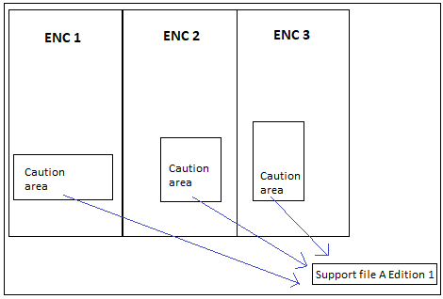
Figure 11-1 – Reference to a new ENC support file

Figure 11-2: Changes occur making it necessary to issue a New Edition of ENC support file A. Edition 1 is no longer valid, and all 3 caution areas refer to the New Edition of ENC support file A (Edition 1 of the file is deleted from the system or not used if no longer referenced by any ENC features):
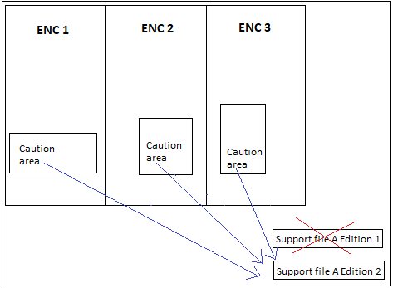
Figure 11-2 – Reference to a New Edition of an ENC support file
Figure 11-3: Changes occur that are only applicable to the Caution areas in ENC 1 and ENC 2. Consequently, these ENCs can no longer refer to ENC support file A Edition 2:
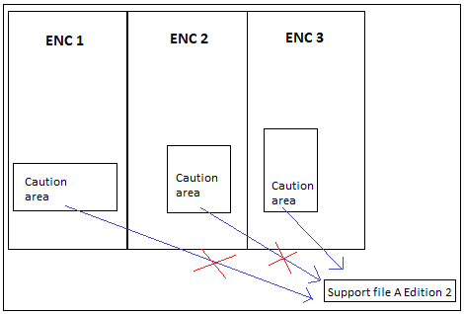
Figure 11-3 – Changes to an ENC support file affecting limited referenced features

Figure 11-4: A new ENC support file B must be created for ENC 1 and ENC 2 to use as reference:
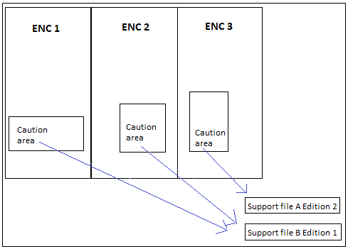
Figure 11-4 – A new ENC support file affecting limited referenced features
NOTE: In Figure 11-4, if the ENC support file A Edition 2 Support File Discovery Metadata attribute “supportedResource” has been populated with all the previous ENC references, then the ENC support file A Edition 2 Support File Discovery Metadata should also be included and updated in the update Exchange Set CATALOG.XML with the “supportedResource” updated accordingly – now referencing only “ENC 3”.
To simplify this process it consideration may be given to not populating the ENC Support File Discovery Metadata attribute “supportedResource” where the ENC support file is referenced in more than one ENC product (see S-100 Part 17, clause 17-4.3.1 – Supported resources / multiple references guide).

Associated XML Metadata file
An associated XML Metadata file is expected to carry information specific to producing authorities’ internal production procedures, and is not intended for use within the end user systems.
If used, all associated XML Metadata files must have unique names. The name of the associated XML Metadata file should not be used to describe the physical content of the file.
The associated XML Metadata file must be named according to the specification given below:
MD_<data file base name>.XML

S-101 Exchange Catalogue
The S-101 Exchange Catalogue acts as the table of contents for the S-100 Exchange Set. The Catalogue file of the Exchange Set must be named CATALOG.XML. No other file in the Exchange Set may be named CATALOG.XML. The contents of the S-101 Exchange Catalogue are described in Section 12.

Data integrity and encryption
See S-100 Parts 15 and 17.

Metadata

Introduction
For information exchange, there are several categories of metadata required: metadata about the overall Exchange Catalogue; metadata about each of the datasets contained in the Catalogue; and metadata about the support files that make up the package.
S-100 Part 17, Figures 17-1, 17-6 and 17-7 outline the overall concept of an S-100 Exchange Set for the interchange of geospatial data and its relevant metadata. Figure 17-1 depicts the realization of the ISO 19115-1 and 19115-3 classes which form the foundation of the Exchange Set. The overall structure of S-101 metadata for Exchange Sets is the same as S-100 metadata. Figure 17-6 depicts the structure of the Exchange Set Catalogue and the structure of the Exchange Set as included in S-100 part 17, Figure 17-1 is also described in clause 11.2 above. More detailed information about the various classes is shown in Figure 17-7 and a textual description in the Tables is included at clauses 12.1.1 to 12.1.4 below.
The discovery metadata classes have numerous attributes which expose important information about the ENCs, ENC support files and system support files to be examined without the need to process the data, for example decrypt, decompress, load etc.
System support files, such as Feature and Portrayal Catalogues or codelist dictionary files, can be included in the Exchange Set in support of the end-user system. The attribute “resourcePurpose” of the ENC Support File Discovery Metadata provides a mechanism to “read” and apply these system support files more easily.
The following clauses define the mandatory and optional metadata needed for S-101. In some cases the metadata may be repeated in a national language. If this is the case it is noted in the Remarks column.
In the following clauses, wherever S-101 makes an optional S-100 metadata attribute mandatory (that is, restricts multiplicity from 0.. to 1..), the restricted multiplicity is shown in place of the multiplicity given in S-100 Part 17, and a comment noting the restricted multiplicity has been included in the Remarks column.

Page intentionally left blank

S100_ExchangeCatalogue
The Exchange Catalogue inherits the Dataset Discovery Metadata, Support File Discovery Metadata and Catalogue Discovery Metadata from S-100 Part 17 with additional S-101-specific restrictions.
Name | Description | Mult | Type | Remarks
S100_ExchangeCatalogue | An Exchange Catalogue contains the discovery metadata about the exchange datasets and support files | - |  | -
identifier | Uniquely identifies this Exchange Catalogue | 1 | S100_ExchangeCatalogueIdentifier | 0..1 multiplicity in S-100 restricted to 1 in S-101
contact | Details about the issuer of this Exchange Catalogue | 1 | S100_CataloguePointOfContact | 0..1 multiplicity in S-100 restricted to 1 in S-101
productSpecification | Details about the Product Specifications used for the datasets contained in the Exchange Catalogue | 1,.* | S100_ProductSpecification | The Exchange Catalogue may contain datasets from Product Specifications other than S-101  0..* multiplicity in S-100 restricted to 1..* in S-101
defaultLocale | Default language and character set used for all metadata records in this Exchange Catalogue | 1 | PT_Locale | All datasets conforming to S-101 Product Specification must use English language as default locale  0..1 multiplicity in S-100 restricted to 1 in S-101
otherLocale | Other languages and character sets used for the localized metadata records in this Exchange Catalogue | 0..* | PT_Locale | Required if any localized entries are present in the Exchange Catalogue
exchangeCatalogueDescription | Description of what the Exchange Catalogue contains | 0..1 | CharacterString
exchangeCatalogueComment | Any additional Information | 0..1 | CharacterString
certificates | Signed public key certificates referred to by digital signatures in the Exchange Set | 0..* | S100_SE_CertificateContainerType | Content defined in S-100 Part 15. All certificates used, except the SA root certificate (installed separately by the implementing system) shall be included
dataServerIdentifier | Identifies the data server for the permit | 0..1 | CharacterString
datasetDiscoveryMetadata | Exchange Catalogues may include or reference discovery metadata for the datasets in the Exchange Set | 0..* | Aggregation S100_DatasetDiscoveryMetadata
catalogueDiscoveryMetadata | Metadata for Catalogue | 0..* | Aggregation S100_CatalogueDiscoveryMetadata | Metadata for the Feature, Portrayal, and Interoperability Catalogues, if any
supportFileDiscoveryMetadata | Exchange Catalogues may include or reference discovery metadata for the support files in the Exchange Set | 0..* | Aggregation S100_SupportFileDiscoveryMetadata

S100_ExchangeCatalogueIdentifier
Role Name | Name | Description | Mult | Type | Remarks
Class | S100_ExchangeCatalogueIdentifier | An Exchange Catalogue contains the discovery metadata about the exchange datasets and support files | - | - | The concatenation of identifier and dateTime form the unique name
Attribute | identifier | Uniquely identifies this Exchange Catalogue | 1 | CharacterString | <S100XC:identifier>US_101_20200101_120101_01</S100XC:identifier>
Attribute | dateTime | Creation date and time of the Exchange Catalogue, including time zone | 1 | DateTime | Format: yyyy-mm-ddThh:mm:ssZ

S100_CataloguePointOfContact
Role Name | Name | Description | Mult | Type | Remarks
Class | S100_CataloguePointOfContact | Contact details of the issuer of this Exchange Catalogue | - | - | -
Attribute | organization | The organization distributing this Exchange Catalogue | 1 | CharacterString | This could be an individual producer, value added reseller, etc
Attribute | phone | The phone number of the organization | 0..1 | CI_Telephone
Attribute | address | The address of the organization | 0..1 | CI_Address

S100_DatasetDiscoveryMetadata
Name | Description | Mult | Type | Remarks
S100_DatasetDiscoveryMetadata | Metadata about the individual datasets in the Exchange Catalogue | - | - | -
fileName | Dataset file name | 1 | URI | See S-100 Part 1, clause 1-4.6
description | Short description giving the area or location covered by the dataset | 0..1 | CharacterString | For example, a harbour or port name, between two named locations etc  See also Note 1
datasetID | Dataset ID expressed as a Maritime Resource Name (MRN) | 0..1 | URN | The URN must be an MRN
compressionFlag | Indicates if the resource is compressed | 1 | Boolean | True indicates a compressed dataset resource  False indicates an uncompressed dataset resource
dataProtection | Indicates if the data is encrypted | 1 | Boolean | True indicates an encrypted dataset resource  False indicates an unencrypted dataset resource
protectionScheme | Specification of method used for data protection | 0..1 | S100_ProtectionScheme
digitalSignatureReference | Specifies the algorithm used to compute digitalSignatureValue | 1 | S100_SE_DigitalSignatureReference (see S-100 Part 15)
digitalSignatureValue | Value derived from the digital signature | 1..* | S100_SE_DigitalSignature (see S-100 Part 15) | The value resulting from application of digitalSignatureReference.  Implemented as the digital signature format specified in S-100 Part 15
copyright | Indicates if the dataset is copyrighted | 1 | Boolean | True indicates the resource is copyrighted  False indicates the resource is not copyrighted
classification | Indicates the security classification of the dataset | 1 | Class  MD_SecurityConstraints>MD_ClassificationCode (codelist) | 1. unclassified  2. restricted  3. confidential  4. secret  5. top secret  6. sensitive but unclassified  7. for official use only  8. protected  9. limited distribution  0..1 multiplicity in S-100 restricted to 1 in S-101
purpose | The purpose for which the dataset has been issued | 1 | S100_Purpose | 0..1 multiplicity in S-100 restricted to 1 in S-101
notForNavigation | Indicates the dataset is not intended to be used for navigation | 1 | Boolean | True indicates the dataset is not intended to be used for navigation  False indicates the dataset is intended to be used for navigation
specificUsage | The use for which the dataset is intended | 0..1 | MD_USAGE>specificUsage (character string)
editionNumber | The Edition number of the dataset | 1 | Integer | When a dataset is initially created, the Edition number 1 is assigned to it. The Edition number is increased by 1 at each New Edition. Edition number remains the same for update and re-issue  0..1 multiplicity in S-100 restricted to 1 in S-101
updateNumber | Update number assigned to the dataset and increased by one for each subsequent update | 1 | Integer | Update number 0 is assigned to a new dataset  0..1 multiplicity in S-100 restricted to 1 in S-101
updateApplicationDate | This date is only used for the base cell files (that is new data set, re-issue and new edition), not update cell files. All updates dated on or before this date must have been applied by the producer | 0..1 | Date
referenceID | Reference back to the datasetID | 0..1 | URN | Update metadata refers to the datasetID of the dataset metadata. This is used if and only if the dataset is an update  The URN must be an MRN
issueDate | Date on which the data was made available by the Data Producer | 1 | Date
issueTime | Time of day at which the data was made available by the Data Producer | 0..1 | Time | The S-100 datatype Time
boundingBox | The extent of the dataset limits | 1 | EX_GeographicBoundingBox | 0..1 multiplicity in S-100 restricted to 1 in S-101
temporalExtent | Specification of the temporal extent of the dataset | 0..1 | S100_TemporalExtent | The temporal extent is encoded as the date/time of the earliest and latest data records (in coverage datasets) or date/time ranges (in vector datasets)  If there is more than one feature in a dataset, the earliest and latest time values of records in all features are used, which means the earliest and latest values may be from different features  If date/time information for a feature is not encoded in the dataset, it is treated for the purposes of this attribute as extending indefinitely in the appropriate direction on the time axis, limited by the issue date/time or the cancellation or supersession of the dataset  This attribute is encoded if and only if at least one of the start and end of the temporal extent is known
productSpecification | The Product Specification used to create this dataset | 1 | S100_ProductSpecification
producingAgency | Agency responsible for producing the data | 1 | CI_Responsibility>CI_Organisation | See S-100 Part 17, Table 17-3
producerCode | The official IHO S-100 Producer Code from the IHO GI Registry, Producer Code Register | 1 | CharacterString | 0..1 multiplicity in S-100 restricted to 1 in S-101
encodingFormat | The encoding format of the dataset | 1 | S100_EncodingFormat | For S-101 datasets must be ISO/IEC 8211
dataCoverage | Provides information about data coverages within the dataset | 1..* | S100_DataCoverage | 0..* multiplicity in S-100 restricted to 1..* in S-101
comment | Any additional information | 0..1 | CharacterString
defaultLocale | Default language and character set used in the dataset | 0..1 | PT_Locale | In absence of defaultLocale the language is English, UTF-8
otherLocale | Other languages and character sets used in the dataset | 0..* | PT_Locale
metadataPointOfContact | Point of contact for metadata | 0..1 | CI_Responsibility>CI_Individual or  CI_Responsibility>CI_Organisation | Only if metadataPointOfContact is different to producingAgency
metadataDateStamp | Date stamp for metadata | 0..1 | Date | Metadata creation date, which may or may not be the dataset creation date
replacedData | Indicates if a cancelled dataset is replaced by another data file(s) | 0..1 | Boolean | See Note 2
dataReplacement | Dataset name | 0..* | CharacterString | A dataset may be replaced by 1 or more datasets  See Note 2
navigationPurpose | Classification of intended navigation purpose (for Catalogue indexing purposes) | 1 | S100_NavigationPurpose | 0..3 multiplicity in S-100 restricted to 1 in S-101
resourceMaintenance | Information about the frequency of resource updates, and the scope of those updates | 0..1 | MD_MaintenanceInformation | S-100 restricts the multiplicity to 0..1 and adds specific restrictions on the ISO 19115 structure and content. See clause MD_MaintenanceInformation later in this Part  Format: PnYnMnDTnHnMnS (XML built-in type for ISO 8601 duration). See S-100 Part 17, clause 17-4.9

NOTE 1: description: During the ENC Dual-Fuel transition period, it is recommended that the attribute description is used to identify equivalent S-57 ENCs in S-101. This information is to be semicolon separated to distinguish it from any other information, for example for 1 to 1 mapping <XC:description>;GB5DNABH;</XC:description> and for more than one equivalent S-57 ENC: <XC:description>;NL4NZ110;NL5WS130;</XC:description>. If the mapping is partial, a “p” should be included at the end of the S-57 dataset name, for example <XC:description>;GB5DNABHp;</XC:description>. There may be scenarios for non-ECDIS use only, where S-101 ENCs are produced without equivalent S-57 ENCs; this should be shown using an “n” as <XC:description>;n;</XC:description>
NOTE 2: replacedData and dataReplacement: The attribute replacedData is mandatory if the attribute purpose (see clause 12.1.2.3) is set to value 5 (cancellation). The attribute dataReplacement is mandatory if replacedData = True.

S100_NavigationPurpose
Item | Name | Description | Code | Remarks
Enumeration | S100_NavigationPurpose | The purpose of the dataset | -
Value | port | For port and near shore operations | 1 | -
Value | transit | For coast and planning purposes | 2 | -
Value | overview | For ocean crossing and planning purposes | 3 | -

S100_DataCoverage
Name | Mult | Value | Type | Remarks
S100_DataCoverage | - | - | - | -
boundingPolygon | 1 |  | EX_BoundingPolygon
temporalExtent | 0..1 |  | S100_TemporalExtent | The remarks for temporalExtent in the dataset discovery block (S100_DatasetDiscoveryMetadata) apply, except that their scope is the individual coverage and not the dataset as a whole
optimumDisplayScale | 1 |  | Integer | Must be one of the following values:  1000  2000  3000  4000  8000  12000  22000  45000  90000  180000  350000  700000  1500000  3500000  10000000  0..1 multiplicity in S-100 restricted to 1 in S-101
maximumDisplayScale | 1 |  | Integer | Any value  0..1 multiplicity in S-100 restricted to 1 in S-101
minimumDisplayScale | 1 |  | Integer | Must be one of the following values:  2000  3000  4000  8000  12000  22000  45000  90000  180000  350000  700000  1500000  3500000  10000000  NULL  0..1 multiplicity in S-100 restricted to 1 in S-101

S100_Purpose
Item | Name | Description | Code | Remarks
Enumeration | S100_Purpose | The purpose of the dataset | -
Value | newDataset | Brand new dataset | 1 | No data has previously been produced for this area
Value | newEdition | New edition of the dataset or Catalogue | 2 | Includes new information which has not been previously distributed by updates
Value | update | Dataset update | 3 | Changing some information in an existing dataset
Value | reissue | Dataset that has been re-issued | 4 | Includes all the updates applied to the original dataset up to the date of the re-issue. A re-issue does not contain any new information additional to that previously issued by updates
Value | cancellation | Dataset or Catalogue that has been cancelled | 5 | Indicates the dataset or Catalogue should no longer be used and can be deleted

S100_TemporalExtent
Role Name | Name | Description | Mult | Type | Remarks
Class | S100_TemporalExtent | Temporal extent | -- |  | At least one of the timeInstantBegin and timeInstantEnd attributes must be populated; if both are known, both must be populated. The absence of either begin or end indicates indefinite validity in the corresponding direction, limited by the issue date/time or the cancellation or supersession of the dataset
Attribute | timeInstantBegin | The instant at which the temporal extent begins | 0..1 | DateTime
Attribute | timeInstantEnd | The instant at which the temporal extent ends | 0..1 | DateTime

S100_EncodingFormat
Item | Name | Description | Code | Remarks
Enumeration | S100_EncodingFormat | The encoding format | - | Values listed in S-100 Part 17 but not mentioned in this table are not allowed
Value | ISO/IEC 8211 | The ISO 8211 data format as defined in S-100 Part 10a | 1

S100_ProductSpecification
Role Name | Name | Description | Mult | Type | Remarks
Class | S100_ProductSpecification | The Product Specification contains the information needed to build the specified product | - | - | -
Attribute | name | The name of the Product Specification used to create the datasets | 1 | CharacterString | Electronic Navigational Chart  0..1 multiplicity in S-100 restricted to 1 in S-101
Attribute | version | The version number of the Product Specification | 1 | CharacterString | 2.0.0  0..1 multiplicity in S-100 restricted to 1 in S-101
Attribute | date | The version date of the Product Specification | 1 | Date | 0..1 multiplicity in S-100 restricted to 1 in S-101
Attribute | productIdentifier | Machine readable unique identifier of a product type | 1 | CharacterString  (Restricted to Product ID values from the IHO Product Specification Register, in the IHO Geospatial Information (GI) Registry) | “S-101” (without quotes)
Attribute | number | The number (registry index) used to lookup the product in the Product Specification Register | 1 | Integer | From the Product Specification Register in the IHO Geospatial Information (GI) Registry
Attribute | compliancyCategory | The level of compliance of the Product Specification to S-100 | 1 | S100_CompliancyCategory | 0..1 multiplicity in S-100 restricted to 1 in S-101. Needed for S-98 interoperability

S100_CompliancyCategory
Item | Name | Description | Code | Remarks
Enumeration | S100_CompliancyCategory |  | - | All S-101 products fully conforming to this Product Specification would be category3 or category4. (S-101 is expected to be category4, but the requirements for harmonized display are being determined, so category3 is provisionally retained to allow for potential divergences between S-101 and those requirements while both specifications are being finalised. In the absence of specific guidance to the contrary from the S-101 project team use category4)
Value | category3 | IHO S-100 compliant with standard encoding | 3
Value | category4 | IHO S-100 and IMO harmonized display compliant | 4

S100_ProtectionScheme
Item | Name | Description | Code | Remarks
Enumeration | S100_ProtectionScheme | Data protection schemes | - | -
Value | S100p15 | IHO S-100 Part 15 | 1 | See S-100 Part 15

S100_SupportFileDiscoveryMetadata
Name | Description | Mult | Type | Remarks
S100_SupportFileDiscoveryMetadata | Metadata about the individual support files in the Exchange Catalogue | - | - | -
fileName | Name of the support file | 1 | URI | See S-100 Part 1, clause 1-4.6
revisionStatus | The purpose for which the support file has been issued | 1 | S100_SupportFileRevisionStatus | For example new, replacement, etc
editionNumber | The Edition number of the support file | 1 | Integer | When a data set is initially created, the Edition number 1 is assigned to it. The Edition number is increased by 1 at each new Edition. Edition number remains the same for a re-issue
issueDate | Date on which the data was made available by the Data Producer | 0..1 | Date
supportFileSpecification | The specification used to create this file | 0..1 | S100_SupportFileSpecification
dataType | The format of the support file | 1 | S100_SupportFileFormat | Constrained to TXT and TIF – see clause 11.4.1
comment | Optional comment | 0..1 | CharacterString | Any additional Information
compressionFlag | Indicates if the resource is compressed | 1 | Boolean | True indicates a compressed resource  False indicates an uncompressed resource
digitalSignatureReference | Specifies the algorithm used to compute digitalSignatureValue | 1 | S100_SE_DigitalSignatureReference (see Part 15)
digitalSignatureValue | Value derived from the digital signature | 1..* | S100_SE_DigitalSignature (see Part 15) | The value resulting from application of digitalSignatureReference  Implemented as the digital signature format specified in S-100 Part 15
defaultLocale | Default language and character set used in the support file | 0..1 | PT_Locale | A support file is expected to use only one as locale. Additional support files can be created for other locales
supportedResource | Identifier of the resource supported by this support file | 0..* | CharacterString | Conventions for identifiers are detailed in S-100 Part 15. S-100 allows file URI, digital signature or cryptographic hash checksums to be used
resourcePurpose | The purpose of the supporting resource | 0..1 | S100_ResourcePurpose | Identifies how the supporting resource is used

NOTE: The optional S-100 field otherDataTypeDescription is not allowed in S-101.

S100_SupportFileFormat
Item | Name | Description | Code | Remarks
Enumeration | S100_SupportFileFormat | The format used for the support file | - | Values listed in S-100 Part 17 but not mentioned in this table are not allowed
Value | TXT_UTF-8 | UTF-8 text excluding control codes | 1 | This is the only format allowed for a textual ENC Support file
Value | TIFF | Tagged Image File Format | 7 | This is the only format allowed for a pictorial ENC Support file

S100_SupportFileRevisionStatus
Item | Name | Description | Code | Remarks
Enumeration | S100_SupportFileRevisionStatus | The reason for inclusion of the support file in this exchange set | - | -
Value | new | A file which is new | 1 | Signifies a new file
Value | replacement | A file which replaces an existing file | 2 | Signifies a replacement for a file of the same name
Value | deletion | Deletes an existing file | 3 | Signifies deletion of a file of that name

S100_SupportFileSpecification
Role Name | Name | Description | Mult | Type | Remarks
Class | S100_SupportFileSpecification | The standard or specification to which a support file conforms | - | - | -
Attribute | name | The name of the specification used to create the support file | 1 | CharacterString
Attribute | version | The version number of the specification | 0..1 | CharacterString
Attribute | date | The version date of the specification | 0..1 | Date

S100_ResourcePurpose
Item | Name | Description | Code | Remarks
Enumeration | S100_ResourcePurpose | Defines the purpose of the supporting resource | - | -
Value | supportFile | A support file | 1 | An ENC support file
Value | ISO Metadata | Dataset metadata in ISO format | 2 | Not to be used for ENC distribution and use in navigational end-user systems. See clause 11.5
Value | Language Pack | A Language pack | 3 | A system support file
Value | GML Schema | GML Application Schema | 4 | Not used in the S-101 ENC Product Specification
Value | other | A type of resource not otherwise described | 100 | A system support file

S100_CatalogueDiscoveryMetadata
This is an optional element that allows for the delivery of S-101 Feature and Portrayal Catalogues within the Exchange Set.
Name | Description | Mult | Type | Remarks
S100_CatalogueDiscoveryMetadata | Class for S-100 Catalogue metadata | - | - | -
fileName | The name for the Catalogue | 1 | URI | See S-100 Part 1, clause 1-4.6
purpose | The purpose for which the Catalogue has been issued | 0..1 | S100_Purpose | The values must be one of the following:  2. new edition  5. cancellation  Default is new edition
editionNumber | The Edition number of the Catalogue | 1 | Integer | Initially set to 1 for a given productSpecification.number  Increased by 1 for each subsequent New Edition  Uniquely identifies the version of the Catalogue
scope | Subject domain of the Catalogue | 1 | S100_CatalogueScope
versionNumber | The version identifier of the Catalogue | 1 | CharacterString | Human readable version identifier
issueDate | The issue date of the Catalogue | 1 | Date
productSpecification | The Product Specification used to create this file | 1 | S100_ProductSpecification
digitalSignatureReference | Specifies the algorithm used to compute digitalSignatureValue | 1 | S100_SE_DigitalSignatureReference (see Part 15) | Reference to the appropriate digital signature algorithm
digitalSignatureValue | Value derived from the digital signature | 1..* | S100_SE_DigitalSignature (see Part 15) | The value resulting from application of digitalSignatureReference  Implemented as the digital signature format specified in Part 15
compressionFlag | Indicates if the resource is compressed | 1 | Boolean | True indicates a compressed resource  False indicates an uncompressed resource
defaultLocale | Default language and character set used in the Catalogue | 1 | PT_Locale | 0..1 multiplicity in S-100 restricted to 1 in S-101
otherLocale | Other languages and character sets used in the Catalogue | 0..* | PT_Locale

S100_CatalogueScope
Item | Name | Description | Code | Remarks
Enumeration | S100_CatalogueScope | The scope of the Catalogue | - | -
Value | featureCatalogue | S-100 Feature Catalogue | 1
Value | portrayalCatalogue | S-100 Portrayal Catalogue | 2
Value | interoperabilityCatalogue | S-100 Interoperability Catalogue | 3

MD_MaintenanceInformation
Role Name | Name | Description | Mult | Type | Remarks
Class | MD_MaintenanceInformation | Information about the scope and frequency of updating | - | - | S-100 restricts the ISO 19115-class to:  - prohibit maintenanceScope, maintenanceNote, and contact attributes;  - define restrictions on maintenanceAndUpdate‌Frequency, maintenanceDate, and userDefinedMaintenance‌Frequency attributes
Attribute | maintenanceAndUpdateFrequency | Frequency with which changes and additions are made to the resource after the initial resource is completed | 0..1 | MD_MaintenanceFrequencyCode (codelist) | Must be populated if userDefinedMaintenanceFrequency is not present, otherwise optional. See Table MD_Maintenance‌Frequency‌Code in this Part for values allowed in S-100 metadata
Attribute | maintenanceDate | Date information associated with maintenance of the resource | 0..1 | CI_Date | Exactly one of maintenanceDate and userDefinedMaintenanceFrequency must be populated  Allowed value for dateType: nextUpdate
Attribute | userDefinedMaintenanceFrequency | Maintenance period other than those defined | 0..1 | TM_PeriodDuration | Exactly one of maintenanceDate and userDefinedMaintenanceFrequency must be populated  Only positive durations allowed

MD_MaintenanceFrequencyCode
S-100 uses a subset of the values allowed in ISO 19115-1.
Item | Name | Description | Code | Remarks
Enumeration | MD_MaintenanceFrequencyCode | Frequency with which modifications and deletions are made to the data after it is first produced | - | S-100 is restricted to only the following values from the ISO 19115-1 codelist. The conditions for the use of a particular value are described in its Remarks
Value | asNeeded | Resource is updated as deemed necessary | 1 | Use only for datasets which normally use a regular interval for update or supersession, but will have the next update issued at an interval different from the usual  Allowed if and only if userDefinedMaintenanceFrequency is not populated
Value | irregular | Resource is updated in intervals that are uneven in duration | 2 | Use only for datasets which do not use a regular schedule for update or supersession  Allowed if and only if userDefinedMaintenanceFrequency is not populated

PT_Locale
Role Name | Name | Description | Mult | Type | Remarks
Class | PT_Locale | description of a locale | - | - | From ISO 19115-1
Value | language | designation of the locale language | 1 | LanguageCode | ISO 639-2 3-letter language codes.
Value | country | designation of the specific country of the locale language | 0..1 | CountryCode | ISO 3166-2 2-letter country codes
Value | characterEncoding | designation of the character set to be used to encode the textual value of the locale | 1 | MD_CharacterSetCode | UTF-8 is used in S-100

The class PT_Locale is defined in ISO 19115-1. LanguageCode, CountryCode, and MD_CharacterSetCode are ISO codelists which are defined in a resource file in the S-100 Edition 5.0.0 Schemas distribution.

Language
The exchange language must be English. Other languages may be used as a supplementary option. National geographic names can be left in their original national language using the complex attribute feature name.
Character strings must be encoded using the character set defined in ISO 10646-1, in Unicode Transformation Format-8 (UTF-8). A BOM (byte order mark) must not be used.

ANNEX A - Data Classification and Encoding Guide
The “Data Classification and Encoding Guide” has been developed to provide consistent, standardized instructions for encoding S-100 compliant ENC data. This document has been laid out, as far as possible, along the lines of the IHO publication S-4, Part B “Chart Specifications of the IHO – Medium and Large-Scale National and International (INT) Charts”.
The purpose of the Data Classification and Encoding Guide is to facilitate S-101 encoding to meet IHO standards for the proper display of ENC in an S-100 based marine navigation system such as ECDIS. The document describes how to encode information that the cartographer considers relevant to an ENC. The content of an ENC is at the discretion of the Producing Authority provided that the conventions described within this document are followed. A “Producing Authority” is a Hydrographic Office (HO) or an organization authorized by a government, HO or other relevant government institution to produce ENCs.
The S-101 Data Classification and Encoding Guide can be found in the Standards and Publications page of the IHO web site, http://www.iho.int.

Page intentionally left blank

ANNEX B (Normative) - Data Product format (encoding)

Introduction
S-101 uses the S-100 profile of ISO/IEC 8211 (refer to S-100 Part 10A) to encapsulate data. This Annex specifies the interchange format to facilitate the moving of files containing data records between computer systems. It defines a specific structure which can be used to transmit files containing data type and data structures specific to S-101.

- Dataset Files
The order of data records in each base or update dataset file is described below:
Dataset file
Dataset General Information record
Dataset Coordinate Reference System record
Information Type records
Point records
Multi Point records
Curve records
Composite Curve records
Surface records
Feature Type records
For Information Type records, Composite Curve records, and Feature Type records it must be ensured that any record that is referenced is stored before the record that references it.

- Records
Records and fields that do not appear in the following tree structure diagrams are prohibited. The order of records in the files must be the same as that described in these tree structure diagrams.
The combination of the file name and the “Name” of the record must provide a unique world-wide identifier of the record. The “Name” of the record is the combination of the subfields RCNM and RCID in the appropriate Identifier field of the record.

- Fields
For base dataset files, some fields may be repeated (indicated by <0..*> or <1..*>) and all of their content may be repeated (indicated by *). In order to reduce the volume of data, the encoder should repeat the sequence of subfields, in preference to creating several fields.

- Subfields
Mandatory subfields must be filled by a non-null value.
Prohibited subfields must be encoded as missing subfields values. The exact meaning of missing attribute values is defined in Annex A.
In the Tables following the tree structure diagrams, prescribed values are indicated in the “Values” column.
When encoding new base datasets the Record Update Instruction (RUIN) subfield must be set to “Insert”. When encoding updates RUIN may be set to “Insert”, “Modify” or “Delete”.

- Base Dataset Structure
NOTE: The number contained in parenthesis () is the number of subfields that are contained in the field.
Base dataset file
|
|--<1>- Dataset General Information record
| |
| |--<1>-DSID (13\\*1): Dataset Identification field
| |
| |--<1>-DSSI (13): Dataset Structure Information field
| |
| |--<0..1>-ATCS (*2): Attribute Codes field
| |
| |--<0..1>-ITCS (*2): Information Type Codes field
| |
| |--<0..1>-FTCS (*2): Feature Type Codes field
| |
| |--<0..1>-IACS (*2): Information Association Codes field
| |
| |-<0..1>-FACS (*2): Feature Association Codes field
| |
| |-<0..1>-ARCS (*2): Association Role Codes field
|
|
|--<1>--Dataset Coordinate Reference System record
| |
| |--<1>-CSID (3): Coordinate Reference System Record Identifier field
| |
| |--<1..*>-CRSH (7): Coordinate Reference System Header field
| |
| |--<0..1>-CSAX (*2): Coordinate System Axes field
| |
| |--<0..1>-VDAT (4): Vertical Datum field
|
|
|--<0..*>--Information Type record
| |
| |--<1>-IRID (5): Information Type Record Identifier field
| |
| |--<0..*>- ATTR (*5): Attribute field
| |
| |--<0..*>- INAS (5\\*5): Information Association field
|
|
|--<0..*>-- Point record
| |
| |--<1>-PRID (4): Point Record Identifier field
| |
| |-<0..*>-INAS (5\\*5): Information Association field
| |
| | alternate coordinate representations
| |
| *-<1>-C2IT (2): 2-D Integer Coordinate Tuple field
| |
| *-<1>-C3IT (4): 3-D Integer Coordinate Tuple field
|
|
|--<0..*>-- Multi Point record
| |
| |--<1>-MRID (4): Multi Point Record Identifier field
| |
| |-<0..*>-INAS (5\\*5): Information Association field
| |
| | alternate coordinate representations
| |
| *-<0..*>-C2IL (*2): 2-D Integer Coordinate List field
| |
| *-<1..*>-C3IL (1\\*3): 3-D Integer Coordinate List field
|
|
|--<0..*>-- Curve record
| |
| |--<1>-CRID (4): Curve Record Identifier field
| |
| |-<0..*>-INAS (5\\*5): Information Association field
| |
| |-<1>-PTAS (*3): Point Association field
| |
| |-<1>-SEGH (1): Segment Header field
| |
| |-<1..*>-C2IL (*2): 2-D Integer Coordinate List field
|
|
|--<0..*>-- Composite Curve record
| |
| |--<1>-CCID (4): Composite Curve Record Identifier field
| |
| |-<0..*>-INAS (5\\*5): Information Association field
| |
| |-<1..*>-CUCO (*3): Curve Component field
|
|
|--<0..*>-- Surface record
| |
| |--<1>-SRID (4): Surface Record Identifier field
| |
| |-<0..*>-INAS (5\\*5): Information Association field
| |
| |-<1..*>-RIAS (*5): Ring Association Field
|
|
|--<0..*>-- Feature Type record
|
|--<1>-FRID (5): Feature Type Record Identifier field
|
|-<1>-FOID (3): Feature Object Identifier field
|
|-<0..*>-ATTR (*5): Attribute field
|
|-<0..*>-INAS (5\\*5): Information Association field
|
|-<0..*>-SPAS (*6): Spatial Association field
|
|-<0..*>-FASC (5\\*5): Feature Association field
|
|-<0..*>-MASK (*4): Masked Spatial Type field

  - Field content
    - Dataset Identification field - DSID
Subfield name | Label | Value | Format | Subfield content and specification
Record name | RCNM | {10} | b11 | {10} – Data Set Identification
Record identification number | RCID | {1} | b14 | Only one record
Encoding specification | ENSP | “S-100 Part 10a” | A() | Encoding specification that defines the encoding
Encoding specification edition | ENED | “5.2” | A() | Edition of the encoding specification
Product identifier | PRSP | “INT.IHO.S-101.2.1” | A() | Unique identifier for the data product as specified in the Product Specification
Product edition | PRED | “2.1” | A() | Edition of the Product Specification
Application profile | PROF | “1” | A() | “1” – Base dataset profile
Dataset file identifier | DSNM |  | A() | The file identifier including the extension but excluding any path information
Dataset title | DSTL |  | A() | The title of the dataset
Dataset reference date | DSRD |  | A(8) | The reference date of the dataset  Format: YYYYMMDD according to ISO 8601
Dataset language | DSLG | “EN” | A() | The (primary) language used in this dataset
Dataset abstract | DSAB | omitted | A() | The abstract of the dataset
Dataset edition | DSED |  | A() | [edition number].[update number] for example 1.0
Dataset topic category | *DSTC | {14}{18} | b11 | A set of topic categories

    - Dataset Structure Information field - DSSI
Subfield name | Label | Value | Format | Subfield content and specification
Dataset Coordinate Origin X | DCOX | {0.0} | b48 | Shift used to adjust x-coordinate before encoding
Dataset Coordinate Origin Y | DCOY | {0.0} | b48 | Shift used to adjust y-coordinate before encoding
Dataset Coordinate Origin Z | DCOZ | {0.0} | b48 | Shift used to adjust z-coordinate before encoding
Coordinate multiplication factor for x-coordinate | CMFX | {10⁷} | b14 | Floating point to integer multiplication factor for the x-coordinate or longitude
Coordinate multiplication factor for y-coordinate | CMFY | {10⁷} | b14 | Floating point to integer multiplication factor for the y-coordinate or latitude
Coordinate multiplication factor for z-coordinate | CMFZ | {10} | b14 | Floating point to integer multiplication factor for the z-coordinate or depths or height
Number of Information Type records | NOIR |  | b14 | Number of information records in the dataset
Number of Point records | NOPN |  | b14 | Number of point records in the dataset
Number of Multi Point records | NOMN |  | b14 | Number of multi point records in the dataset
Number of Curve records | NOCN |  | b14 | Number of curve records in the dataset
Number of Composite Curve records | NOXN |  | b14 | Number of composite curve records in the dataset
Number of Surface records | NOSN |  | b14 | Number of surface records in the dataset
Number of Feature Type records | NOFR |  | b14 | Number of feature records in the dataset

    - Attribute Code field structure - ATCS
Subfield name | Label | Value | Format | Subfield content and specification
Attribute Code | *ATCD |  | A() | The code as defined in the Feature Catalogue
Attribute Numeric Code | ANCD |  | b12 | The code used within the NATC subfield

    - Information Type Codes field structure - ITCS
Subfield name | Label | Value | Format | Subfield content and specification
Information Type Code | *ITCD |  | A() | The code as defined in the Feature Catalogue
Information Type Numeric Code | ITNC |  | b12 | The code used within the NITC subfield

    - Feature Type Codes field structure - FTCS
Subfield name | Label | Value | Format | Subfield content and specification
Feature Type Code | *FTCD |  | A() | The code as defined in the Feature Catalogue
Feature Type Numeric Code | FTNC |  | b12 | The code used within the NFTC subfield

    - Information Association Codes field structure - IACS
Subfield name | Label | Value | Format | Subfield content and specification
Information Association Code | *IACD |  | A() | The code as defined in the Feature Catalogue
Information Association Numeric Code | IANC |  | b12 | The code used within the NIAC subfield

    - Feature Association Codes field structure - FACS
Subfield name | Label | Value | Format | Subfield content and specification
Feature Association Code | *FACD |  | A() | The code as defined in the Feature Catalogue
Feature Association Numeric Code | FANC |  | b12 | The code used within the NFAC subfield

    - Association Role Codes field structure - ARCS
Subfield name | Label | Value | Format | Comment
Association Role Code | *ARCD |  | A() | The code as defined in the Feature Catalogue
Association Role Numeric Code | ARNC |  | b12 | The code used within the NARC subfield

    - Coordinate Reference System Record Identifier field - CSID
Subfield name | Label | Value | Format | Subfield content and specification
Record Name | RCNM | {15} | b11 | {15} - Coordinate Reference System Identifier
Record identification number | RCID | {1} | b14 | Only one record
Number of CRS Components | NCRC |  | b11 | {1} - Single CRS (No C3IT or C3IL fields in the dataset)  >{1} - Compound CRS

    - Coordinate Reference System Header field - CRSH
Subfield name | Label | Value | Format | Subfield content and specification
CRS Index | CRIX |  | b11 | 1 – for the horizontal CRS  >1 – for the vertical CRSs
CRS Type | CRST | {1} or {5} | b11 | {1} – 2D Geographic  {5} – Vertical
Coordinate System Type | CSTY | {1} or {3} | b11 | {1} – Ellipsoidal CS  {3} – Vertical CS
CRS Name | CRNM |  | A() | The name of the CRS
CRS Identifier | CRSI | “4326” – for horizontal CRS  omitted for vertical CRS | A()
CRS Source | CRSS | {2} for horizontal CRS  {255} for vertical CRS | b11 | {2} – EPSG  {255} – Not Applicable
CRS Source Information | SCRI | omitted | A()

    - Coordinate System Axes field - CSAX
This field is only used for vertical CRS.
Subfield name | Label | Value | Format | Subfield content and specification
Axis Type | *AXTY | {12} | b11 | {12} – Gravity related depth (orientation down)
Axis Unit of Measure | AXUM | {4} | b11 | {4} – Metre

    - Vertical Datum field - VDAT
This field is only used for vertical CRS.
Subfield name | Label | Value | Format | Subfield content and specification
Datum Name | DTNM |  | A() | Name of the vertical datum as defined in the Feature Catalogue
Datum Identifier | DTID | “verticalDatum:x” where x is the enumeration value in the Feature Catalogue | A() | Identifier of the datum in an external source
Datum Source | DTSR | {2} | b11 | {2} – Feature Catalogue
Datum Source Information | SCRI | omitted | A()

    - Information Type Identifier field - IRID
Subfield name | Label | Value | Format | Subfield content and specification
Record Name | RCNM | {150} | b11 | {150} – Information Type
Record identification number | RCID |  | b14 | Range: 1 to 2³²-2
Numeric Information Type Code | NITC |  | b12 | A valid information type code as defined in the ITCS field of the Dataset General Information Record
Record version | RVER |  | b12 | RVER contains the serial number of the record edition
Record update instruction | RUIN | {1} | b11 | {1} – Insert

    - Attribute field - ATTR
Subfield name | Label | Value | Format | Subfield content and specification
Numeric attribute code | *NATC |  | b12 | A valid attribute code as defined in the ATCS field of the Dataset General Information Record
Attribute index | ATIX |  | b12 | Index (position) of the attribute in the sequence of attributes with the same code and the same parent (starting with 1)
Parent index | PAIX |  | b12 | Index (position) of the parent complex attribute within this ATTR field (starting with 1). If the attribute has no parent (top level attribute) the value is 0
Attribute instruction | ATIN | {1} | b11 | {1} - Insert
Attribute value | ATVL |  | A() | A string containing a valid value for the domain of the attribute specified by the subfields above

    - Information Association field - INAS
Subfield name | Label | Value | Format | Subfield content and specification
Referenced Record name | RRNM | {150} | b11 | Record name of the referenced record  {150} – Information Type
Referenced Record identifier | RRID |  | b14 | Record identifier of the referenced record
Numeric Information Association Code | NIAC |  | b12 | A valid code for the information association as defined in the IACS field of the Dataset General Information Record
Numeric Association Role Code | NARC |  | b12 | A valid code for the role as defined in the ARCS field of the Dataset General Information Record
Information Association Update Instruction | IUIN |  | b11 | {1} – Insert
Numeric attribute code | *NATC |  | b12 | A valid attribute code as defined in the ATCS field of the Dataset General Information Record
Attribute index | ATIX |  | b12 | Index (position) of the attribute in the sequence of attributes with the same code and the same parent (starting with 1)
Parent index | PAIX |  | b12 | Index (position) of the parent complex attribute within this INAS field (starting with 1). If the attribute has no parent (top level attribute) the value is 0
Attribute Instruction | ATIN |  | b11 | {1} – Insert  {2} – Delete  {3} – Modify
Attribute value | ATVL |  | A() | A string containing a valid value for the domain of the attribute specified by the subfields above

    - Point Record Identifier field - PRID
Subfield name | Label | Value | Format | Subfield content and specification
Record name | RCNM | {110} | b11 | {110} – Point
Record identification number | RCID |  | b14 | Range: 1 to 2³²-2
Record version | RVER |  | b12 | RVER contains the serial number of the record edition
Record update instruction | RUIN | {1} | b11 | {1} – Insert

    - 2-D Integer Coordinate Tuple field structure - C2IT
Subfield name | Label | Value | Format | Subfield content and specification
Coordinate in Y axis | YCOO |  | b24 | Y-coordinate or latitude
Coordinate in X axis | XCOO |  | b24 | X-coordinate or longitude

    - 3-D Integer Coordinate Tuple field structure - C3IT
Subfield name | Label | Value | Format | Subfield content and specification
Vertical CRS Id | VCID |  | b11 | Internal identifier of the Vertical CRS
Coordinate in Y axis | YCOO |  | b24 | Y-coordinate or latitude
Coordinate in X axis | XCOO |  | b24 | X-coordinate or longitude
Coordinate in Z axis | ZCOO |  | b24 | Z-coordinate (depth)

    - Multi Point Record Identifier field - MRID
Subfield name | Label | Value | Format | Subfield content and specification
Record name | RCNM | {115} | b11 | {115} – Multi Point
Record identification number | RCID |  | b14 | Range: 1 to 2³²-2
Record version | RVER |  | b12 | RVER contains the serial number of the record edition
Record update instruction | RUIN | {1} | b11 | {1} – Insert

    - 2-D Integer Coordinate List field structure - C2IL
Subfield name | Label | Format | Subfield content and specification
Coordinate in Y axis | *YCOO | b24 | Y-coordinate or latitude
Coordinate in X axis | XCOO | b24 | X-coordinate or longitude

    - 3-D Integer Coordinate List field structure - C3IL
Subfield name | Label | Format | Subfield content and specification
Vertical CRS Id | VCID | b11 | Internal identifier of the Vertical CRS
Coordinate in Y axis | *YCOO | b24 | Y-coordinate or latitude
Coordinate in X axis | XCOO | b24 | X-coordinate or longitude
Coordinate in Z axis | ZCOO | b24 | Z-coordinate (depth)

    - Curve Record Identifier field - CRID
Subfield name | Label | Value | Format | Subfield content and specification
Record name | RCNM | {120} | b11 | {120} – Curve
Record identification number | RCID |  | b14 | Range: 1 to 2³²-2
Record version | RVER |  | b12 | RVER contains the serial number of the record edition
Record update instruction | RUIN | {1} | b11 | {1} – Insert

    - Point Association field - PTAS
Subfield name | Label | Value | Format | Subfield content and specification
Referenced Record name | *RRNM | {110} | b11 | Record name of the referenced record  {110} – Point
Referenced Record identifier | RRID |  | b14 | Record identifier of the referenced record
Topology indicator | TOPI |  | b11 | {1} – Beginning point  {2} – End point  {3} – Beginning & End point

    - Segment Header field - SEGH
Subfield name | Label | Value | Format | Subfield content and specification
Interpolation | INTP | {4} | b11 | {4} – Loxodromic

    - Composite Curve Record Identifier field - CCID
Subfield name | Label | Value | Format | Subfield content and specification
Record name | RCNM | {125} | b11 | {125} – Composite Curve
Record identification number | RCID |  | b14 | Range: 1 to 2³²-2
Record version | RVER |  | b12 | RVER contains the serial number of the record edition
Record update instruction | RUIN | {1} | b11 | {1} – Insert

    - Curve Component field - CUCO
Subfield name | Label | Value | Format | Subfield content and specification
Referenced Record name | *RRNM | {120} or {125} | b11 | Record name of the referenced record  {120} – Curve  {125} – Composite Curve
Referenced Record identifier | RRID |  | b14 | Record identifier of the referenced record
Orientation | ORNT |  | b11 | {1} – Forward  {2} – Reverse

    - Surface Record Identifier field - SRID
Subfield name | Label | Value | Format | Subfield content and specification
Record name | RCNM | {130} | b11 | {130} – Surface
Record identification number | RCID |  | b14 | Range: 1 to 2³²-2
Record version | RVER |  | b12 | RVER contains the serial number of the record edition
Record update instruction | RUIN | {1} | b11 | {1} – Insert

    - Ring Association field - RIAS
Subfield name | Label | Value | Format | Subfield content and specification
Referenced Record name | *RRNM | {120} or {125} | b11 | Record name of the referenced record  {120} – Curve  {125} – Composite Curve
Referenced Record identifier | RRID |  | b14 | Record identifier of the referenced record
Orientation | ORNT |  | b11 | {1} – Forward  {2} – Reverse
Usage indicator | USAG |  | b11 | {1} – Exterior  {2} – Interior
Ring Association update instruction | RAUI | {1} | b11 | {1} – Insert

    - Feature Type Record Identifier field - FRID
Subfield name | Label | Value | Format | Subfield content and specification
Record name | RCNM | {100} | b11 | {100} - Feature type
Record identification number | RCID |  | b14 | Range: 1 to 2³²-2
Numeric Feature Type Code | NFTC |  | b12 | A valid feature type code as defined in the FTCS field of the Dataset General Information Record
Record version | RVER |  | b12 | RVER contains the serial number of the record edition
Record update instruction | RUIN | {1} | b11 | {1} – Insert

    - Feature Object Identifier field - FOID
Subfield name | Label | Value | Format | Subfield content and specification
Producing agency | AGEN |  | b12 | Agency code
Feature identification number | FIDN |  | b14 | Range: 1 to 2³²-2
Feature identification subdivision | FIDS |  | b12 | Range: 1 to 2¹⁶-2

    - Spatial Association field - SPAS
Subfield name | Label | Value | Format | Subfield content and specification
Referenced Record name | *RRNM | One of  {110}  {115}  {120}  {125}  {130} | b11 | Record name of the referenced record  {110} – Point  {115} – Multi Point  {120} – Curve  {125} – Composite Curve  {130} – Surface
Referenced Record identifier | RRID |  | b14 | Record identifier of the referenced record
Orientation | ORNT |  | b11 | {1} – Forward  {2} – Reverse  {255} – NULL (Not Applicable)
Scale Minimum | SMIN |  | b14 | {2³²-1} – NULL (Not Applicable) – (see Note)
Scale Maximum | SMAX |  | b14 | {2³²-1} – NULL (Not Applicable) – (see Note)
Spatial Association Update Instruction | SAUI | {1} | b11 | {1} – Insert

NOTE: For a correct handling of older data, robust parsers should consider both 0 and 2³²-1 as ‘Not Applicable’ for the SMIN and the SMAX sub-field.
    - Feature Association field – FASC
Subfield name | Label | Value | Format | Subfield content and specification
Referenced Record name | RRNM | {100} | b11 | Record name of the referenced record  {100} – Feature Type
Referenced Record identifier | RRID |  | b14 | Record identifier of the referenced record
Numeric Feature Association Code | NFAC |  | b12 | A valid code for the feature association as defined in the FACS field of the Dataset General Information Record
Numeric Association Role Code | NARC |  | b12 | A valid code for the role as defined in the ARCS field of the Dataset General Information Record
Feature Association Update Instruction | FAUI | {1} | b11 | {1} – Insert
Numeric Attribute Code | *NATC |  | b12 | A valid attribute code as defined in the ATCS field of the Dataset General Information Record
Attribute index | ATIX |  | b12 | Index (position) of the attribute in the sequence of attributes with the same code and the same parent (starting with 1)
Parent index | PAIX |  | b12 | Index (position) of the parent complex attribute within this FASC field (starting with 1). If the attribute has no parent (top level attribute) the value is 0
Attribute Instruction | ATIN |  | b11 | {1} – Insert
Attribute value | ATVL |  | A() | A string containing a valid value for the domain of the attribute specified by the subfields above

    - Masked Spatial Type field - MASK
Subfield name | Label | Value | Format | Subfield content and specification
Referenced Record name | *RRNM | {120} or {125} | b11 | Record name of the referenced record  {120} – Curve  {125} – Composite Curve
Referenced Record identifier | RRID |  | b14 | Record identifier of the referenced record
Mask Indicator | MIND | {1} or {2} | b11 | {1} – Truncated by the data coverage limit  {2} – Suppress portrayal
Mask Update Instruction | MUIN | {1} | b11 | {1} – Insert

- Update Dataset Structure
Update dataset file
|
|--<1>- Dataset General Information record
| |
| |--<1>-DSID (13\\*1): Dataset Identification field
| |
| |--<1>-DSSI (13): Dataset Structure Information field
| |
| |--<0..1>-ATCS (*2): Attribute Codes field
| |
| |--<0..1>-ITCS (*2): Information Type Codes field
| |
| |--<0..1>-FTCS (*2): Feature Type Codes field
| |
| |--<0..1>-IACS (*2): Information Association Codes field
| |
| |-<0..1>-FACS (*2): Feature Association Codes field
| |
| |-<0..1>-ARCS (*2): Association Role Codes field
|
|
|--<0..*>--Information Type record
| |
| |--<1>-IRID (5): Information Type Record Identifier field
| |
| |--<0..*>- ATTR (*5): Attribute field
| |
| |--<0..*>- INAS (5\\*5): Information Association field
|
|
|--<0..*>-- Point record
| |
| |--<1>-PRID (4): Point Record Identifier field
| |
| |-<0..*>-INAS (5\\*5): Information Association field
| |
| | alternate coordinate representations
| |
| *-<0..1>-C2IT (2): 2-D Integer Coordinate Tuple field
| |
| *-<0..1>-C3IT (4): 3-D Integer Coordinate Tuple field
|
|
|--<0..*>-- Multi Point record
| |
| |--<1>-MRID (4): Multi Point Record Identifier field
| |
| |-<0..*>-INAS (5\\*5): Information Association field
| |
| |-<0..1>-COCC (3): Coordinate Control field
| |
| | alternate coordinate representations
| |
| *-<0..*>-C2IL (*2): 2-D Integer Coordinate List field
| |
| *-<1..*>-C3IL (1\\*3): 3-D Integer Coordinate List field
|
|
|--<0..*>-- Curve record
| |
| |--<1>-CRID (4): Curve Record Identifier field
| |
| |-<0..*>-INAS (5\\*5): Information Association field
| |
| |-<0..1>-PTAS (*3): Point Association field
| |
| |-<0..1>-SECC (3): Segment Control field
| |
| |-<0..1>-SEGH (1): Segment Header field
| |
| |-<0..1>-COCC (3): Coordinate Control Field
| |
| |-<0..*>-C2IL (*2): 2-D Integer Coordinate List field
|
|
|--<0..*>-- Composite Curve record
| |
| |--<1>-CCID (4): Composite Curve Record Identifier field
| |
| |-<0..*>-INAS (5\\*5): Information Association field
| |
| |-<0..1>-CCOC (3): Curve Component Control field
| |
| |-<0..*>-CUCO (*3): Curve Component field
|
|
|--<0..*>-- Surface record
| |
| |--<1>-SRID (4): Surface Record Identifier field
| |
| |-<0..*>-INAS (5\\*5): Information Association field
| |
| |-<0..*>-RIAS (*5): Ring Association Field
|
|
|--<0..*>-- Feature Type record
|
|--<1>-FRID (5): Feature Type Record Identifier field
|
|-<0..1>-FOID (3): Feature Object Identifier field
|
|-<0..*>-ATTR (*5): Attribute field
|
|-<0..*>-INAS (5\\*5): Information Association field
|
|-<0..*>-SPAS (*6): Spatial Association field
|
|-<0..*>-FASC (*5): Feature Association field
|
|-<0..*>-MASK (*4): Masked Spatial Type field

  - Field content
    - Dataset Identification field - DSID
Subfield name | Label | Value | Format | Subfield content and specification
Record name | RCNM | {10} | b11 | {10} – Data Set Identification
Record identification number | RCID | {1} | b14 | Only one record
Encoding specification | ENSP | “S-100 Part 10a” | A() | Encoding specification that defines the encoding
Encoding specification edition | ENED | “5.2” | A() | Edition of the encoding specification
Product identifier | PRSP | “INT.IHO.S-101.2.1” | A() | Unique identifier for the data product as specified in the Product Specification
Product edition | PRED | “2.1” | A() | Edition of the Product Specification
Application profile | PROF | “2” | A() | “2” – Update dataset profile
Dataset file identifier | DSNM |  | A() | The file identifier including the extension but excluding any path information
Dataset title | DSTL |  | A() | The title of the dataset
Dataset reference date | DSRD |  | A(8) | The reference date of the dataset  Format: YYYYMMDD according to ISO 8601
Dataset language | DSLG | “EN” | A() | The (primary) language used in this dataset
Dataset abstract | DSAB | omitted | A() | The abstract of the dataset
Dataset edition | DSED |  | A() | [edition number].[update number] for example 4.20
Dataset topic category | *DSTC | {14}{18} | b11 | A set of topic categories

    - Dataset Structure Information field - DSSI
Subfield name | Label | Value | Format | Subfield content and specification
Dataset Coordinate Origin X | DCOX | {0.0} | b48 | Shift used to adjust x-coordinate before encoding
Dataset Coordinate Origin Y | DCOY | {0.0} | b48 | Shift used to adjust y-coordinate before encoding
Dataset Coordinate Origin Z | DCOZ | {0.0} | b48 | Shift used to adjust z-coordinate before encoding
Coordinate multiplication factor for x-coordinate | CMFX | {10⁷} | b14 | Floating point to integer multiplication factor for the x-coordinate or longitude
Coordinate multiplication factor for y-coordinate | CMFY | {10⁷} | b14 | Floating point to integer multiplication factor for the y-coordinate or latitude
Coordinate multiplication factor for z-coordinate | CMFZ | {10} | b14 | Floating point to integer multiplication factor for the z-coordinate or depths or height
Number of Information Type records | NOIR |  | b14 | Number of information records in the dataset
Number of Point records | NOPN |  | b14 | Number of point records in the dataset
Number of Multi Point records | NOMN |  | b14 | Number of multi point records in the dataset
Number of Curve records | NOCN |  | b14 | Number of curve records in the dataset
Number of Composite Curve records | NOXN |  | b14 | Number of composite curve records in the dataset
Number of Surface records | NOSN |  | b14 | Number of surface records in the dataset
Number of Feature Type Records | NOFR |  | b14 | Number of feature records in the dataset

    - Attribute Code field structure - ATCS
Subfield name | Label | Value | Format | Subfield content and specification
Attribute Code | *ATCD |  | A() | The code as defined in the Feature Catalogue
Attribute Numeric Code | ANCD |  | b12 | The code used within the NATC subfield
    - Information Type Codes field structure - ITCS
Subfield name | Label | Value | Format | Subfield content and specification
Information Type Code | *ITCD |  | A() | The code as defined in the Feature Catalogue
Information Type Numeric Code | ITNC |  | b12 | The code used within the NITC subfield

    - Feature Type Codes field structure - FTCS
Subfield name | Label | Value | Format | Subfield content and specification
Feature Type Code | *FTCD |  | A() | The code as defined in the Feature Catalogue
Feature Type Numeric Code | FTNC |  | b12 | The code used within the NFTC subfield

    - Information Association Codes field structure - IACS
Subfield name | Label | Value | Format | Subfield content and specification
Information Association Code | *IACD |  | A() | The code as defined in the Feature Catalogue
Information Association Numeric Code | IANC |  | b12 | The code used within the NIAC subfield

    - Feature Association Codes field structure - FACS
Subfield name | Label | Value | Format | Subfield content and specification
Feature Association Code | *FACD |  | A() | The code as defined in the Feature Catalogue
Feature Association Numeric Code | FANC |  | b12 | The code used within the NFAC subfield

    - Association Role Codes field structure - ARCS
Subfield name | Label | Value | Format | Subfield content and specification
Association Role Code | *ARCD |  | A() | The code as defined in the Feature Catalogue
Association Role Numeric Code | ARNC |  | b12 | The code used within the NARC subfield

    - Information Type Identifier field - IRID
Subfield name | Label | Value | Format | Subfield content and specification
Record name | RCNM | {150} | b11 | {150} – Information Type
Record identification number | RCID |  | b14 | Range: 1 to 2³²-2
Numeric Information Type Code | NITC |  | b12 | A valid information type code as defined in the ITCS field of the Dataset General Information Record
Record version | RVER |  | b12 | RVER contains the serial number of the record edition
Record update instruction | RUIN | {1},{2} or {3} | b11 | {1} – Insert  {2} – Delete  {3} – Modify

    - Attribute field - ATTR
Subfield name | Label | Value | Format | Subfield content and specification
Numeric attribute code | *NATC |  | b12 | A valid attribute code as defined in the ATCS field of the Dataset General Information Record
Attribute index | ATIX |  | b12 | Index (position) of the attribute in the sequence of attributes with the same code and the same parent (starting with 1)
Parent index | PAIX |  | b12 | Index (position) of the parent complex attribute within this ATTR field (starting with 1). If the attribute has no parent (top level attribute) the value is 0
Attribute instruction | ATIN | {1}, {2} or {3} | b11 | {1} – Insert  {2} – Delete  {3} – Modify
Attribute value | ATVL |  | A() | A string containing a valid value for the domain of the attribute specified by the subfields above

    - Information Association field - INAS
Subfield name | Label | Value | Format | Subfield content and specification
Referenced Record name | RRNM | {150} | b11 | Record name of the referenced record  {150} – Information Type
Referenced Record identifier | RRID |  | b14 | Record identifier of the referenced record
Numeric Information Association Code | NIAC |  | b12 | A valid code for the information association as defined in the IACS field of the Dataset General Information Record
Numeric Association Role code | NARC |  | b12 | A valid code for the role as defined in the ARCS field of the Dataset General Information Record
Information Association Update Instruction | IUIN |  | b11 | {1} – Insert  {2} – Delete  {3} – Modify
Numeric Attribute code | *NATC |  | b12 | A valid attribute code as defined in the ATCS field of the Dataset General Information Record
Attribute index | ATIX |  | b12 | Index (position) of the attribute in the sequence of attributes with the same code and the same parent (starting with 1)
Parent index | PAIX |  | b12 | Index (position) of the parent complex attribute within this ATTR field (starting with 1). If the attribute has no parent (top level attribute) the value is 0
Attribute instruction | ATIN |  | b11 | {1} – Insert  {2} – Delete  {3} – Modify
Attribute value | ATVL |  | A() | A string containing a valid value for the domain of the attribute specified by the subfields above

    - Point Record Identifier field - PRID
Subfield name | Label | Value | Format | Subfield content and specification
Record name | RCNM | {110} | b11 | {110} – Point
Record identification number | RCID |  | b14 | Range: 1 to 2³²-2
Record version | RVER |  | b12 | RVER contains the serial number of the record edition
Record update instruction | RUIN | {1},{2} or {3} | b11 | {1} – Insert  {2} – Delete  {3} – Modify

    - 2-D Integer Coordinate Tuple field structure - C2IT
Subfield name | Label | Value | Format | Subfield content and specification
Coordinate in Y axis | YCOO |  | b24 | Y-coordinate or latitude
Coordinate in X axis | XCOO |  | b24 | X-coordinate or longitude

    - 3-D Integer Coordinate Tuple field structure - C3IT
Subfield name | Label | Value | Format | Subfield content and specification
Vertical CRS Id | VCID |  | b11 | Internal identifier of the Vertical CRS
Coordinate in Y axis | YCOO |  | b24 | Y-coordinate or latitude
Coordinate in X axis | XCOO |  | b24 | X-coordinate or longitude
Coordinate in Z axis | ZCOO |  | b24 | Z-coordinate (depth)
    - Multi Point Record Identifier field - MRID
Subfield name | Label | Value | Format | Subfield content and specification
Record name | RCNM | {115} | b11 | {115} – Multi Point
Record identification number | RCID |  | b14 | Range: 1 to 2³²-2
Record version | RVER |  | b12 | RVER contains the serial number of the record edition
Record update instruction | RUIN | {1},{2} or {3} | b11 | {1} – Insert  {2} – Delete  {3} – Modify

    - 2-D Integer Coordinate List field structure - C2IL
Subfield name | Label | Format | Subfield content and specification
Coordinate in Y axis | *YCOO | b24 | Y-coordinate or latitude
Coordinate in X axis | XCOO | b24 | X-coordinate or longitude

    - 3-D Integer Coordinate List field structure - C3IL
Subfield name | Label | Format | Subfield content and specification
Vertical CRS Id | VCID | b11 | Internal identifier of the Vertical CRS
Coordinate in Y axis | *YCOO | b24 | Y-coordinate or latitude
Coordinate in X axis | XCOO | b24 | X-coordinate or longitude
Coordinate in Z axis | ZCOO | b24 | Z-coordinate (depth)

    - Coordinate Control field - COCC
Subfield name | Label | Value | Format | Subfield content and specification
Coordinate Update Instruction | COUI | {1},{2} or {3} | b11 | {1} – Insert  {2} – Delete  {3} – Modify
Coordinate Index | COIX |  | b12 | Index (position) of the addressed coordinate tuple within the coordinate field(s) of the target record
Number of Coordinates | NCOR |  | b12 | Number of coordinate tuples to be inserted, deleted or modified. If COUI is Insert(1) or Modify(3) this is the number of coordinate tuples in the coordinate field(s) of the update record

    - Curve Record Identifier field - CRID
Subfield name | Label | Value | Format | Subfield content and specification
Record name | RCNM | {120} | b11 | {120} – Curve
Record identification number | RCID |  | b14 | Range: 1 to 2³²-2
Record version | RVER |  | b12 | RVER contains the serial number of the record edition
Record update instruction | RUIN | {1},{2} or {3} | b11 | {1} – Insert  {2} – Delete  {3} – Modify

    - Point Association field - PTAS
Subfield name | Label | Value | Format | Subfield content and specification
Referenced Record name | *RRNM | {110} | b11 | Record name of the referenced record  {110} – Point
Referenced Record identifier | RRID |  | b14 | Record identifier of the referenced record
Topology indicator | TOPI |  | b11 | {1} – Beginning point  {2} – End point  {3} – Beginning & End point

    - Segment Control field - SECC
Subfield name | Label | Value | Format | Subfield content and specification
Segment update instruction | SEUI | {1},{2} or {3} | b11 | {1} – Insert  {2} – Delete  {3} – Modify
Segment index | SEIX |  | b12 | Index (position) of the addressed segment in the target record
Number of segments | NSEG |  | b12 | Number of segments to be inserted, deleted or modified. If SEUI is Insert(1) or Modify(3) this is the number of segments in the update record

    - Segment Header field - SEGH
Subfield name | Label | Value | Format | Subfield content and specification
Interpolation | INTP | {4} | b11 | {4} – Loxodromic

    - Composite Curve Record Identifier field - CCID
Subfield name | Label | Value | Format | Subfield content and specification
Record name | RCNM | {125} | b11 | {125} – Composite Curve
Record identification number | RCID |  | b14 | Range: 1 to 2³²-2
Record version | RVER |  | b12 | RVER contains the serial number of the record edition
Record update instruction | RUIN | {1},{2} or {3} | b11 | {1} – Insert  {2} – Delete  {3} – Modify

    - Curve Component Control field - CCOC
Subfield name | Label | Value | Format | Subfield content and specification
Curve Component update instruction | CCUI |  | b11 | {1} – Insert  {2} – Delete  {3} – Modify
Curve Component Index | CCIX |  | b12 | Index (position) of the addressed Curve record pointer within the CUCO field(s) of the target record
Number of Curve Components | NCCO |  | b12 | Number of Curve record pointers to be inserted, deleted or modified. If CCUI is Insert(1) or Modify(3) this is the number of Curve record pointers in the CUCO field(s) of the update record

    - Curve Component field - CUCO
Subfield name | Label | Value | Format | Subfield content and specification
Referenced Record name | *RRNM | {120} or {125} | b11 | Record name of the referenced record  {120} – Curve  {125} – Composite Curve
Referenced Record identifier | RRID |  | b14 | Record identifier of the referenced record
Orientation | ORNT |  | b11 | {1} – Forward  {2} – Reverse

    - Surface Record Identifier field - SRID
Subfield name | Label | Value | Format | Subfield content and specification
Record name | RCNM | {130} | b11 | {130} – Surface
Record identification number | RCID |  | b14 | Range: 1 to 2³²-2
Record version | RVER |  | b12 | RVER contains the serial number of the record edition
Record update instruction | RUIN | {1},{2} or {3} | b11 | {1} – Insert  {2} – Delete  {3} – Modify

    - Ring Association field - RIAS
Subfield name | Label | Value | Format | Subfield content and specification
Referenced Record name | *RRNM | {120} or {125} | b11 | Record name of the referenced record  {120} – Curve  {125} – Composite Curve
Referenced Record identifier | RRID |  | b14 | Record identifier of the referenced record
Orientation | ORNT |  | b11 | {1} – Forward  {2} – Reverse
Usage indicator | USAG |  | b11 | {1} – Exterior  {2} – Interior
Ring Association update instruction | RAUI | {1} or {2} | b11 | {1} – Insert  {2} – Delete

    - Feature Type Record Identifier field - FRID
Subfield name | Label | Value | Format | Subfield content and specification
Record name | RCNM | {100} | b11 | {100} – Feature type
Record identification number | RCID |  | b14 | Range: 1 to 2³²-2
Numeric Feature Type Code | NFTC |  | b12 | A valid feature type code as defined in the FTCS field of the Dataset General Information Record
Record version | RVER |  | b12 | RVER contains the serial number of the record edition
Record update instruction | RUIN | {1},{2} or {3} | b11 | {1} – Insert  {2} – Delete  {3} – Modify

    - Feature Object Identifier field - FOID
Subfield name | Label | Value | Format | Subfield content and specification
Producing agency | AGEN |  | b12 | Agency code
Feature identification number | FIDN |  | b14 | Range: 1 to 2³²-2
Feature identification subdivision | FIDS |  | b12 | Range: 1 to 2¹⁶-2

    - Spatial Association field - SPAS
Subfield name | Label | Value | Format | Subfield content and specification
Referenced Record name | *RRNM | One of  {110} {115} (120} {125} {130} | b11 | Record name of the referenced record  {110} – Point  {115} – Multi Point  {120} – Curve  {125} – Composite Curve  {130} – Surface
Referenced Record identifier | RRID |  | b14 | Record identifier of the referenced record
Orientation | ORNT |  | b11 | {1} – Forward  {2} – Reverse  {255} – NULL (Not Applicable)
Scale Minimum | SMIN |  | b14 | {2³²-1} – NULL (Not Applicable) – (see Note)
Scale Maximum | SMAX |  | b14 | {2³²-1} – NULL (Not Applicable) – (see Note)
Spatial Association Update instruction | SAUI | {1} or {2} | b11 | {1} – Insert  {2} – Delete

NOTE: For a correct handling of older data, robust parsers should consider both 0 and 2³²-1 as ‘Not Applicable’ for the SMIN and the SMAX sub-field.
    - Feature Association field – FASC
Subfield name | Label | Value | Format | Subfield content and specification
Referenced Record name | RRNM | {100} | b11 | Record name of the referenced record  {100} – Feature Type
Referenced Record identifier | RRID |  | b14 | Record identifier of the referenced record
Numeric Feature Association Code | NFAC |  | b12 | A valid code for the feature association as defined in the FACS field of the Dataset General Information Record
Numeric Association Role Code | NARC |  | b12 | A valid code for the role as defined in the ARCS field of the Dataset General Information Record
Feature Association Update Instruction | FAUI | {1} ,{2} or {3} | b11 | {1} – Insert  {2} – Delete  {3} – Modify
Numeric Attribute Code | *NATC |  | b12 | A valid attribute code as defined in the ATCS field of the Dataset General Information Record
Attribute index | ATIX |  | b12 | Index (position) of the attribute in the sequence of attributes with the same code and the same parent (starting with 1)
Parent index | PAIX |  | b12 | Index (position) of the parent complex attribute within this ATTR field (starting with 1). If the attribute has no parent (top level attribute) the value is 0
Attribute Instruction | ATIN | {1},{2} or {3} | b11 | {1} – Insert  {2} – Delete  {3} – Modify
Attribute value | ATVL |  | A() | A string containing a valid value for the domain of the attribute specified by the subfields above

    - Masked Spatial Type field - MASK
Subfield name | Label | Value | Format | Subfield content and specification
Referenced Record name | *RRNM | {120} or {125} | b11 | Record name of the referenced record  {120} – Curve  {125} – Composite Curve
Referenced Record identifier | RRID |  | b14 | Record identifier of the referenced record
Mask Indicator | MIND | {1} or {2} | b11 | {1} – Truncated by the data coverage limit  {2} – Suppress portrayal
Mask Update Instruction | MUIN | {1} or {2} | b11 | {1} – Insert  {2} – Delete

- Dataset Cancellation Structure
Dataset cancelation file
|
|--<1>- Dataset General Information record
|
|--<1>-DSID (13\\*1): Dataset Identification field

  - Field content
    - Dataset Identification field - DSID
Subfield name | Label | Value | Format | Subfield content and specification
Record name | RCNM | {10} | b11 | {10} – Data Set Identification
Record identification number | RCID | {1} | b14 | Only one record
Encoding specification | ENSP | “S-100 Part 10a” | A() | Encoding specification that defines the encoding
Encoding specification edition | ENED | “5.2” | A() | Edition of the encoding specification
Product identifier | PRSP | “INT.IHO.S-101.2.1” | A() | Unique identifier for the data product as specified in the product specification
Product edition | PRED | “2.1” | A() | Edition of the product specification
Application profile | PROF | “2” | A() | “2” – Update dataset profile
Dataset file identifier | DSNM |  | A() | The file identifier including the extension but excluding any path information
Dataset title | DSTL |  | A() | The title of the dataset
Dataset reference date | DSRD |  | A(8) | The reference date of the dataset  Format: YYYYMMDD according to ISO 8601
Dataset language | DSLG | “EN” | A() | The (primary) language used in this dataset
Dataset abstract | DSAB | omitted | A() | The abstract of the dataset
Dataset edition | DSED | “0” | A() | 0 – Indicates the cancellation
Dataset topic category | *DSTC | {14}{18} | b11 | A set of topic categories

